* To apply the changes
  + kubectl apply -f webapp.yaml
* To get all the components in the clusters
  + Kubectl get all
* To get all the pods
  + Kubectl get pod

Orchestore:

Terminology:

* Control Plane Nodes (Master nodes- old jargon)
* High available control plane nodes
  + Usually keep odd number (like 3 or 5) not more than that if it is more than 5 it is difficult to communicate
  + Eg: if we have 3 friends deciding what to eat is easy, if we have more friends like 23 deciding what to eat is a difficult task
* **Kubernetes operates an active passive model where only one control plane node is making active changes to the cluster at any one time. Called Leader**
* **And we call others followers and the followers proxy connections over to the leader so that the leader can make the actions**

**Every control plane node runs a bunch of smaller services that are responsible for individual control plane features.**

**And, every control plane node runs the full set of features. So any one of them can act as a leader**

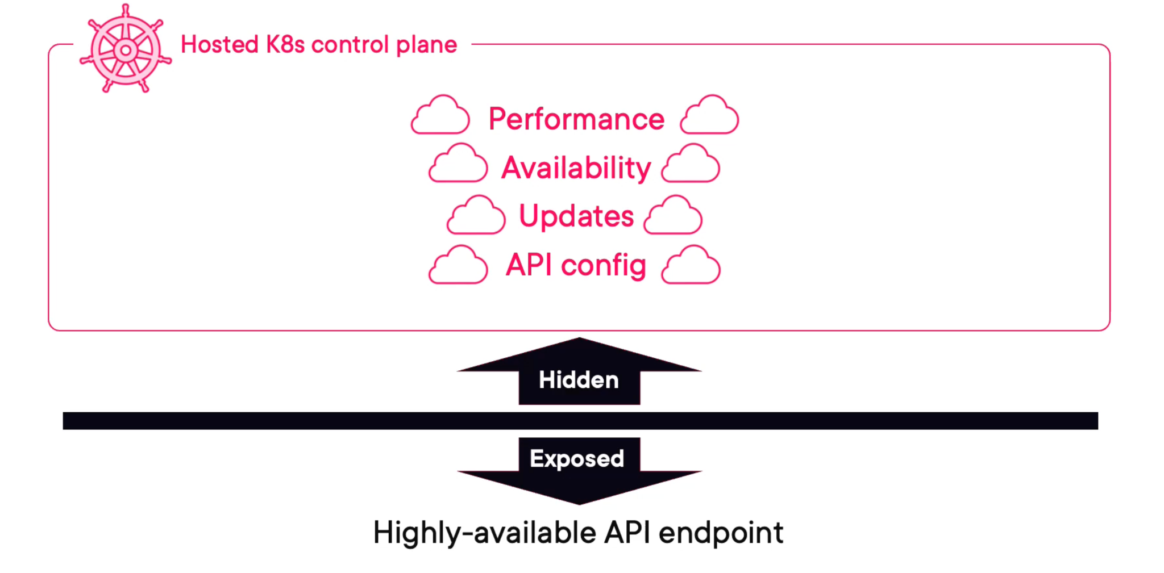

**If we are building a kubernetes yourself, you get to choose the number and the size of your control plane nodes.**

* **But, on a hosted kubernetes platform the control plane is hidden from you, and your cloud provider manages all of that**
* **Cloud providers: Kubernetes AWS Elastic Kubernetes Service, Azure Kubernetes Service, and Google Kubernetes Engine**

**Good Practice:**

* Not to run user apps on control plane nodes. Infact, if you are consuming a hosted kubernetes service, you can’t even see the control plane nodes.

**And In Production:**

* Leave the control plane nodes to focus on the Kubernetes stuff

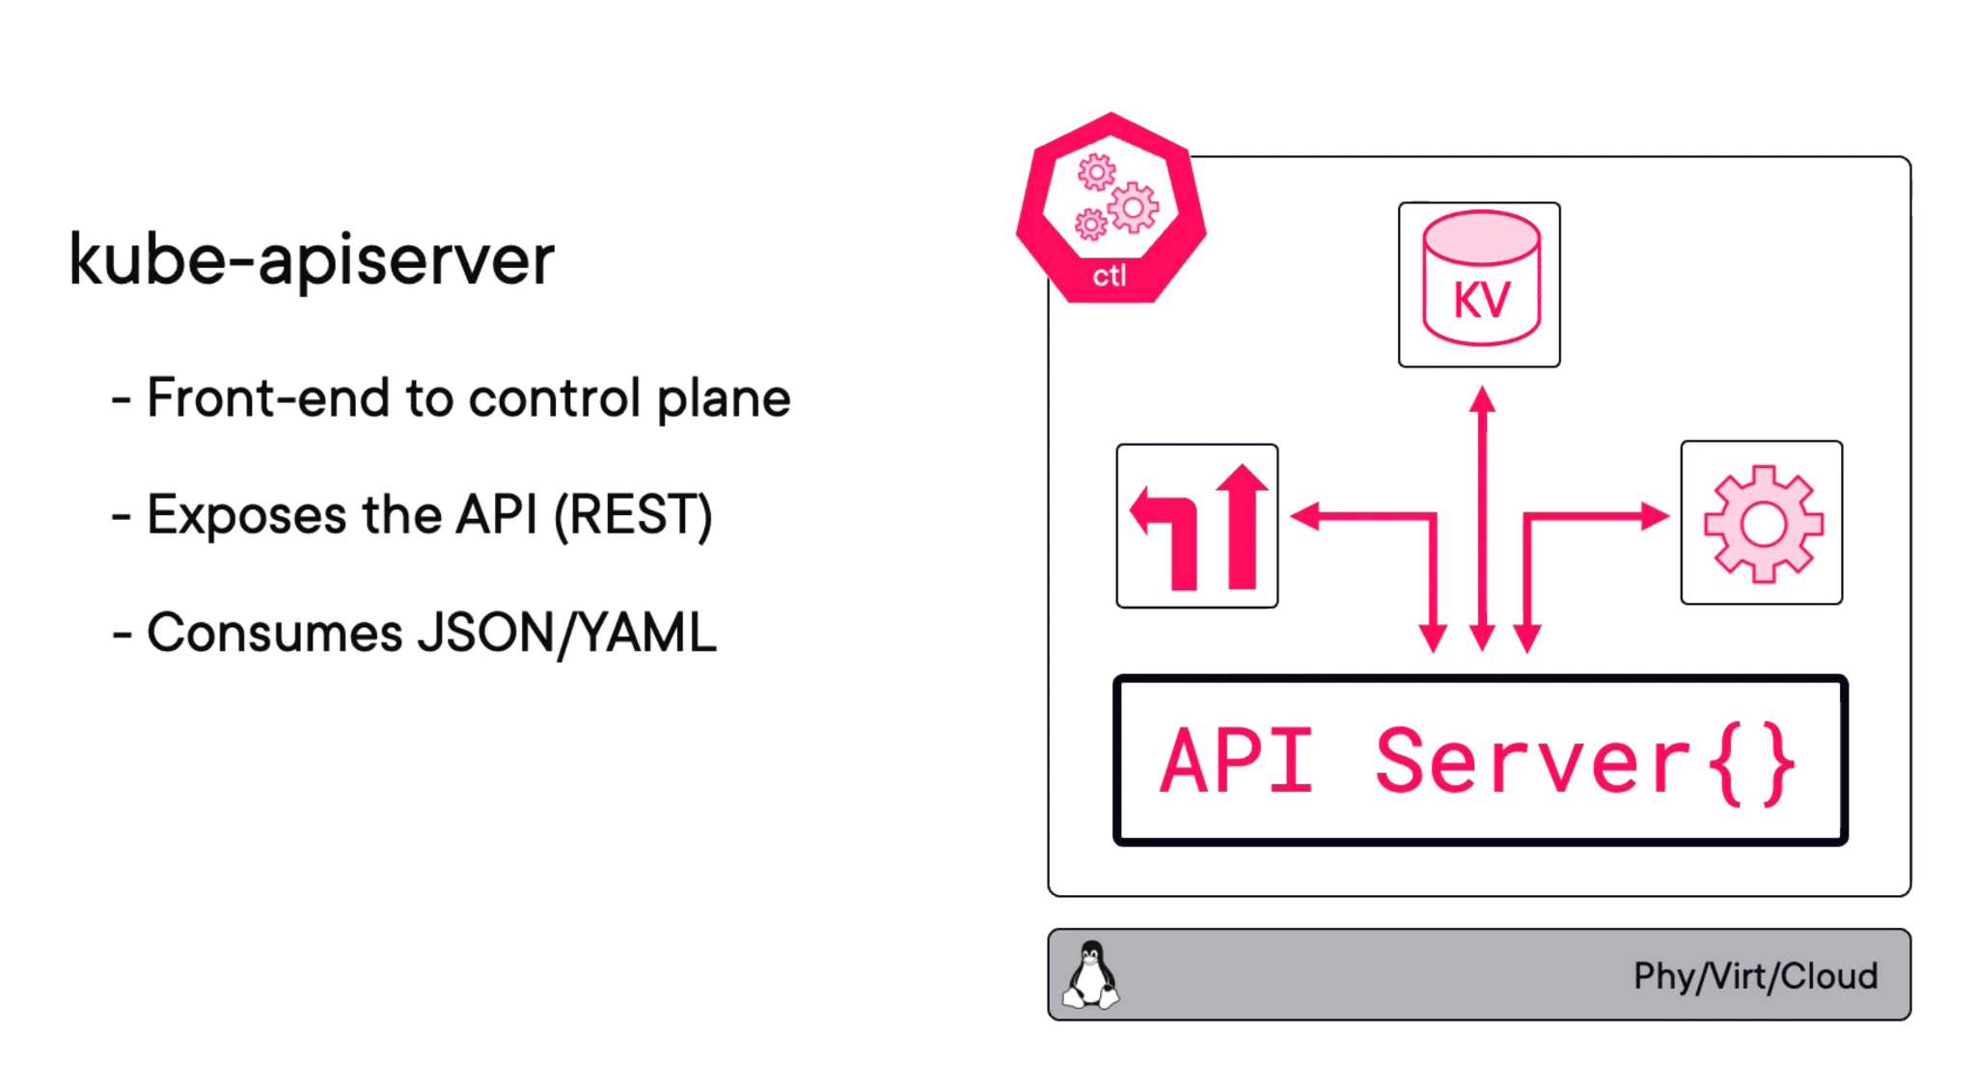

* Every communication is through the API Server between works or between the control planes

**Cluster Store:**

* Persistent component on the entire control plane
* It is based on the **etcd NoSQL** database, and it’s automatically distributed across and it automatically distributed across all control plane nodes

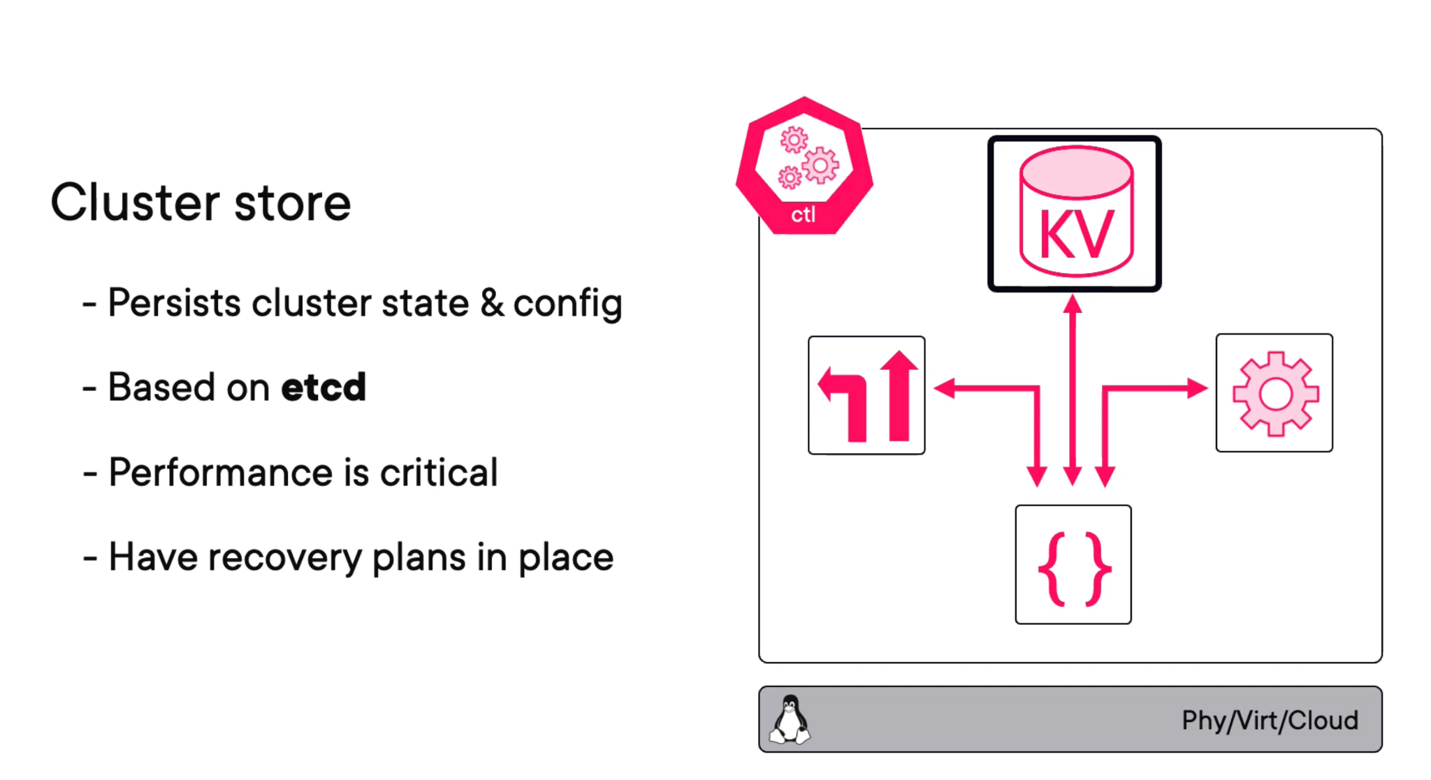

**Kube-controller-manager**

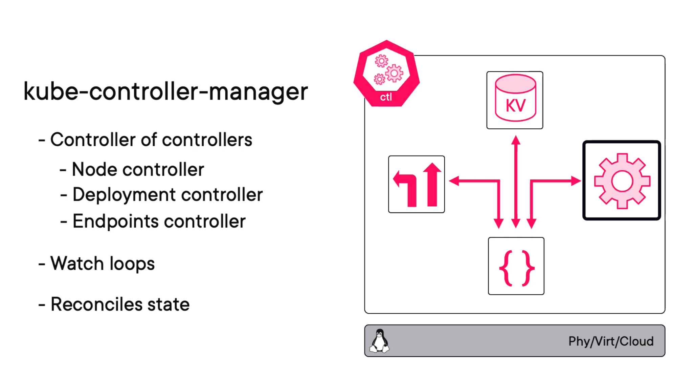

**Kube-Scheduler:**

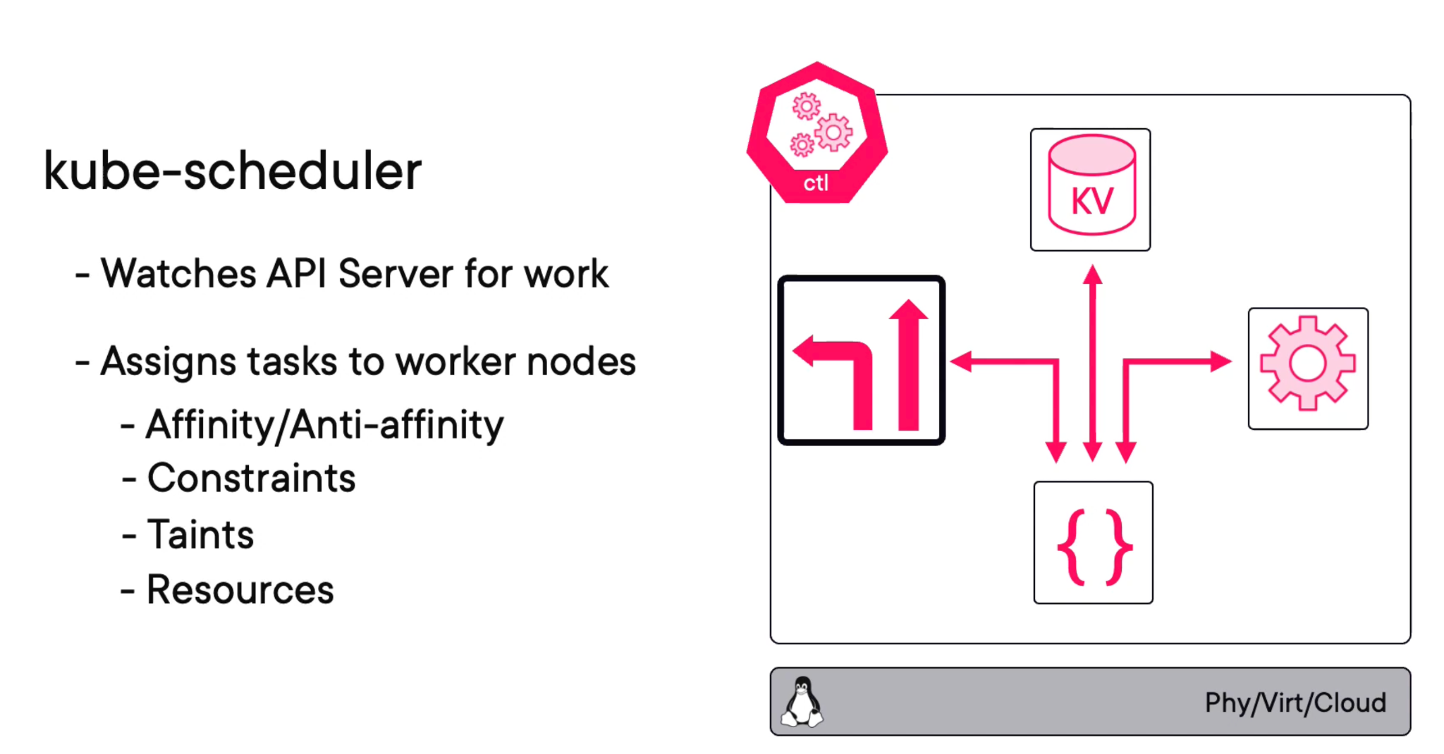

**Whole Picture:**

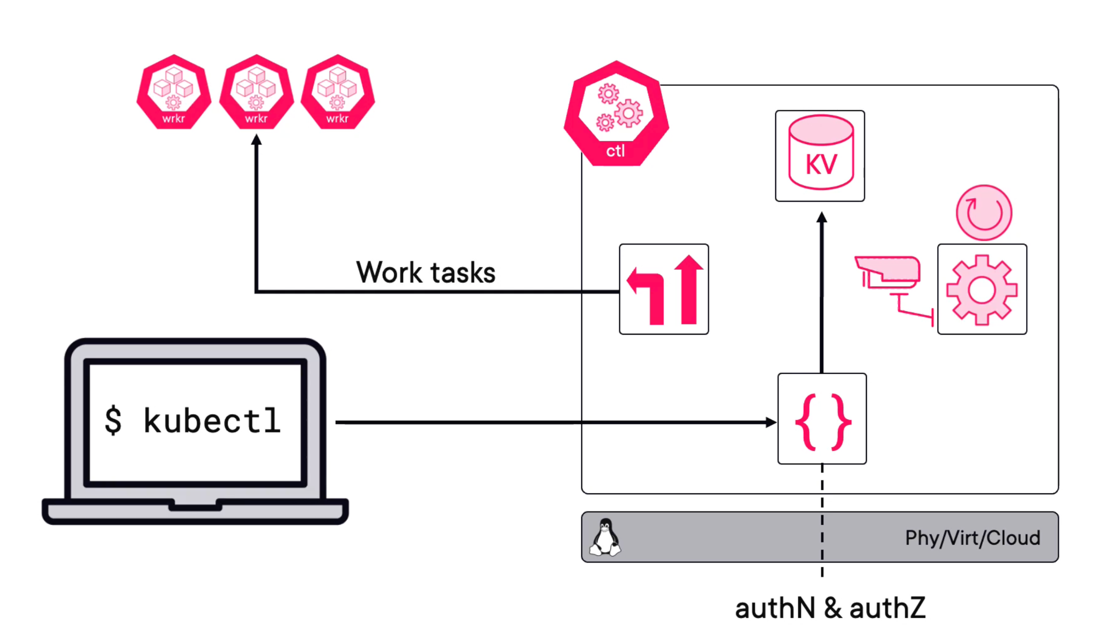

**Worker Nodes:**

**Pod:** One or more container packaged together in a single deployable unit.

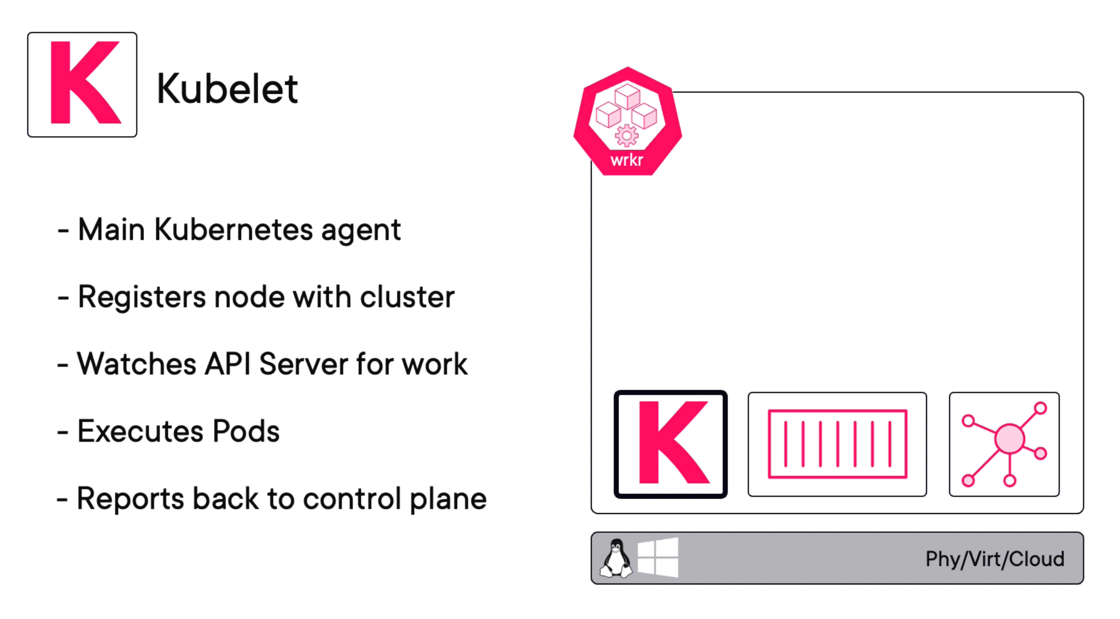

* Kubelet keep the control plane in the loop
* Only kubernetes and the kubelet don’t actually don’t know how to run containers.
  + Like they don’t know how to pull images layers or even talk to the OS kernel to build and start containers for all of that stuff
* For all of that it needs a container run time
* Now in the early days, Kubernetes baked in Docker as its container run time
* But, then it made this whole layer plug able with something called **CONTAINER RUNTIME INTERFACE or the (CRI)**
* **CRI:** It got all the smarts on how to start and stop containers and the likes on most modern kubernetes clusters it is container D but like we just said, its plug and there are tons of other runtime out there (gVisor, katacontainers)

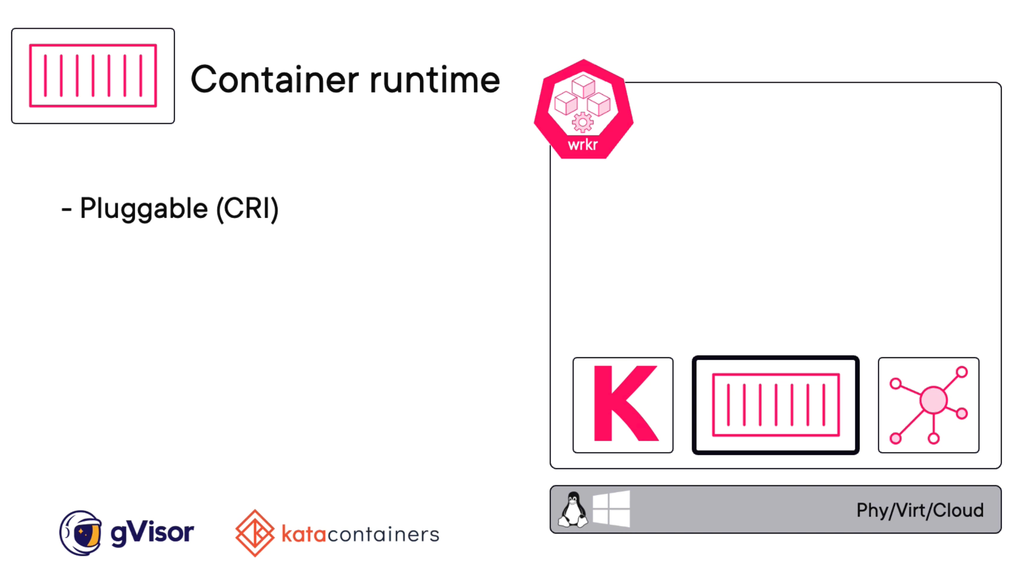

**Kube Proxy:**

* Kinda of like network brains of the node
* It makes sure that every pod running gets an IP and it is one IP per pod.
* So, if you are running multi container pods, so pods with multiple containers in them, all of those containers are going to share the pod single IP
  + Meaning, you are gonna have to **use ports** and the likes if you need if you **like to reach individual containers in the same pod**.

Declarative Model & Desired State:

* Kubernetes operates on a declarative model

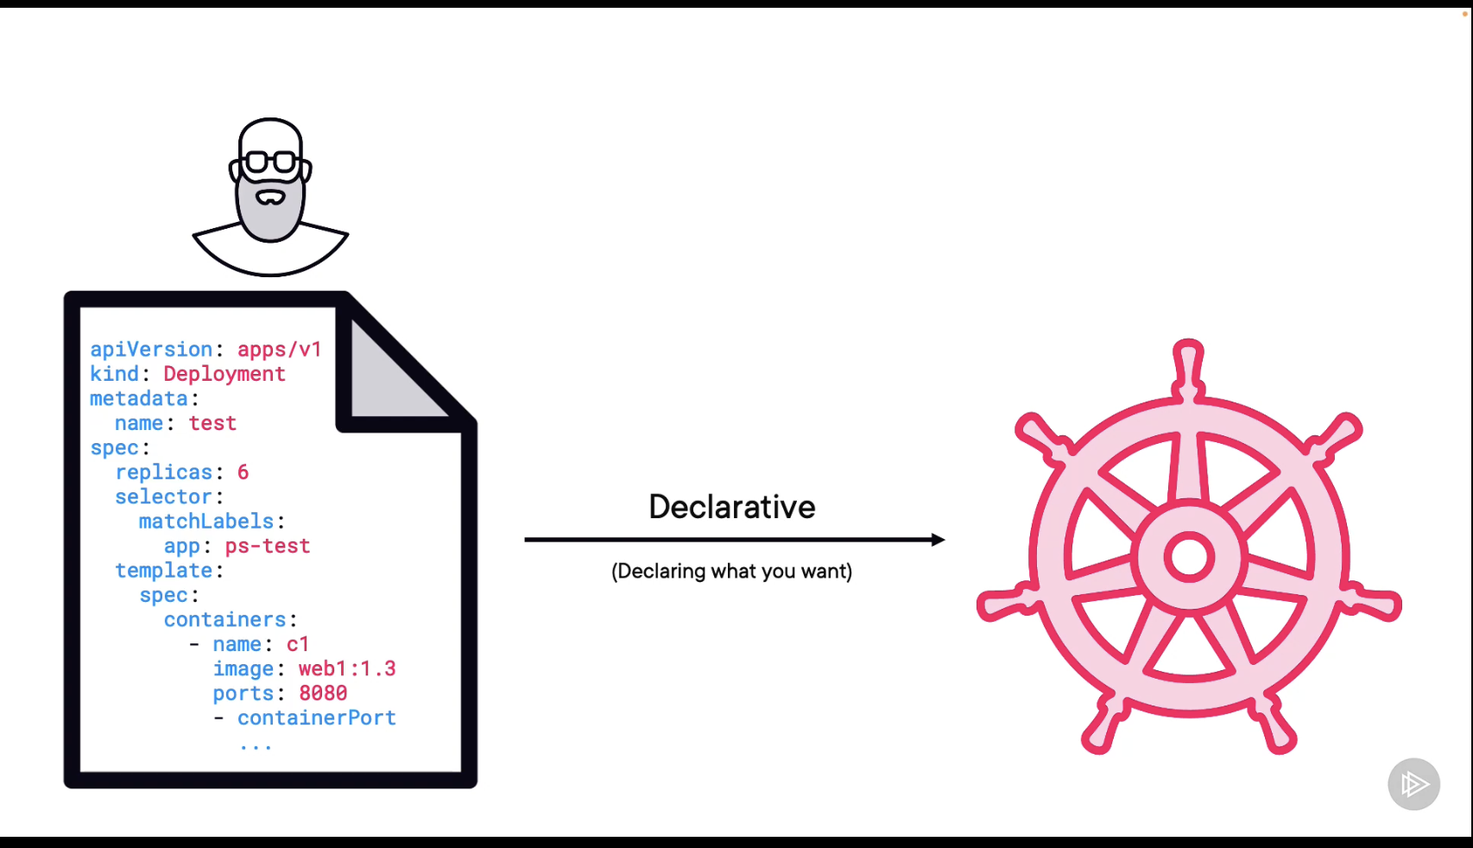

We will Just give config as

* We want 3 replicas

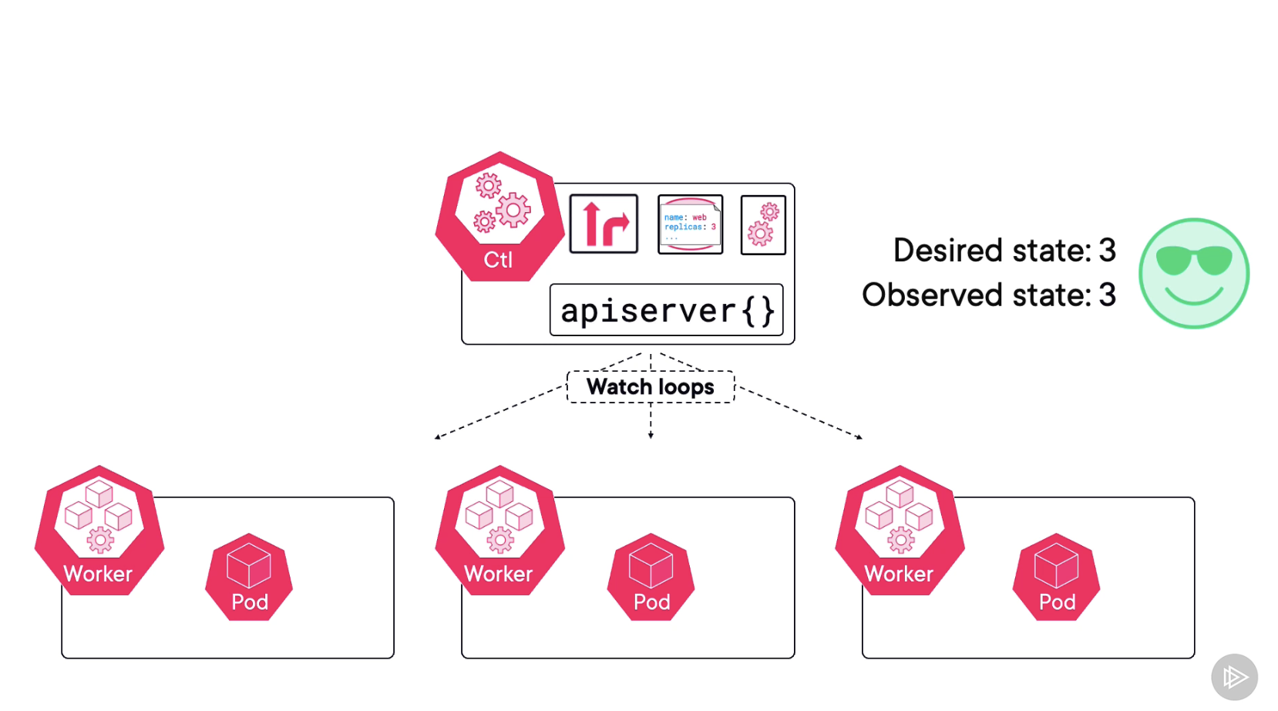

If any one worker goes down then it will reconcile it and make it work

As below

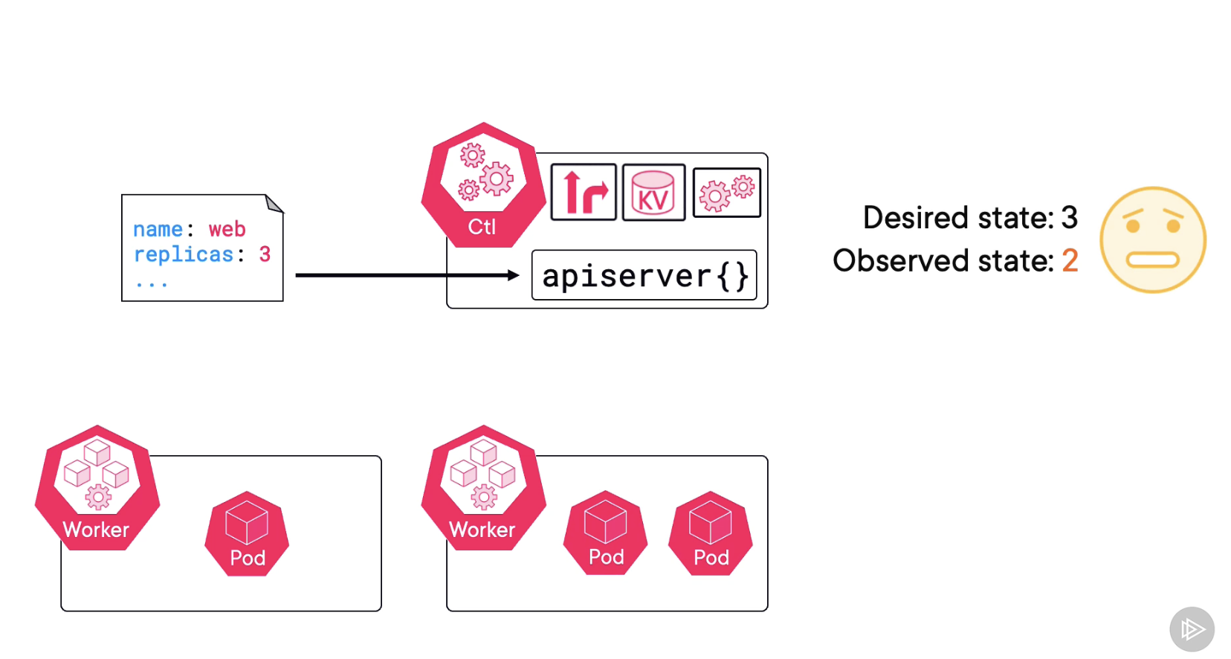

**The Mighty POD:**

* In VM World The atomic unit of deployment is Virtual Machine
* In Docker World, is the **container**
* In Kubernetes World **it is the Pod**
* Kubernetes **runs or orchestrates containers**
* **Only those containers must always run inside of pods**

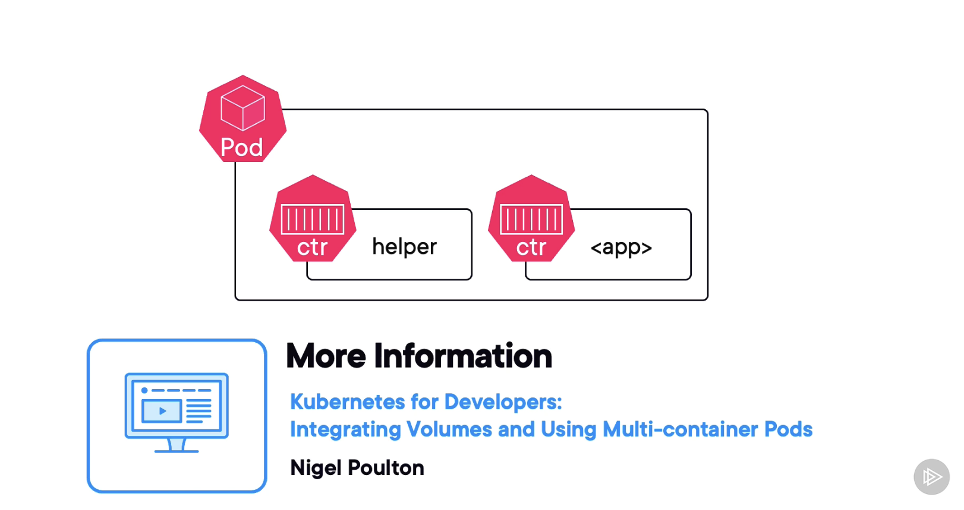

**What is a POD ?**

* A POD is a shared execution environment
  + An shared execution environment is basically a collection of things an app needs to run. Ma
  + Maybe an IP address in a network port, files from a file system, a bit of shared memory

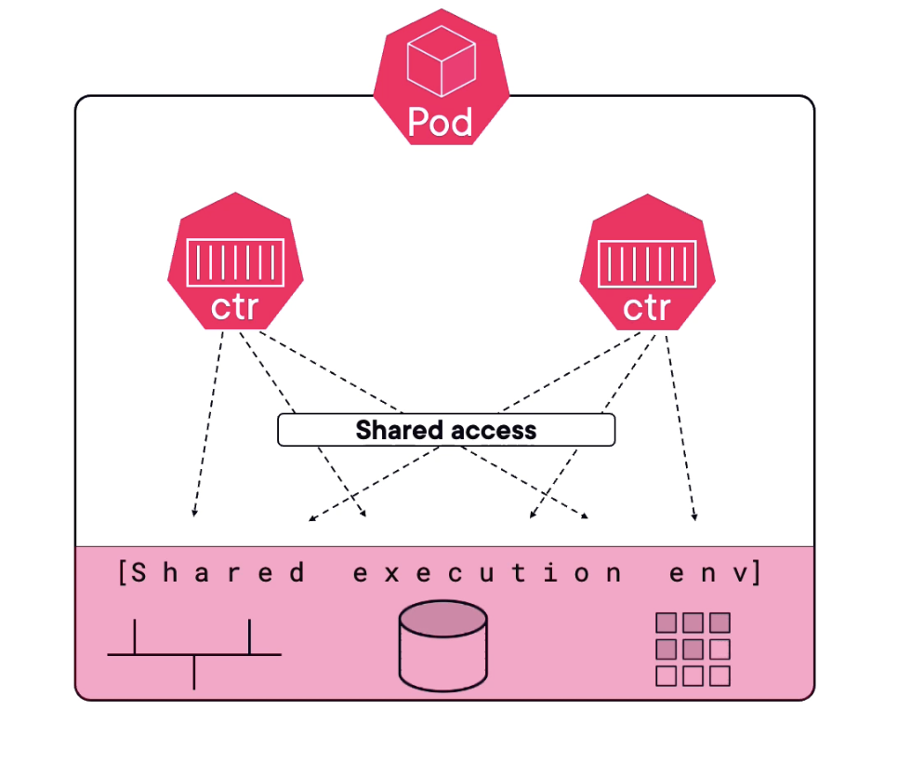

* A POD has a **single IP.**

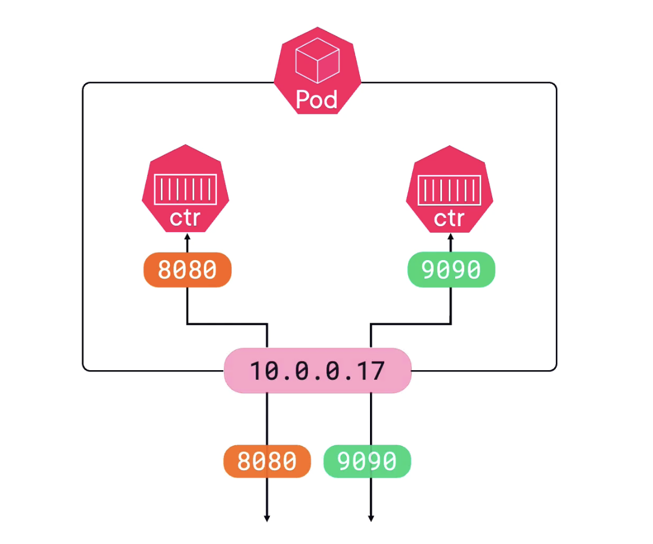

* **If those two containers needs to talk each other inside the pod then they can use same ports over the pods localhost interface.**

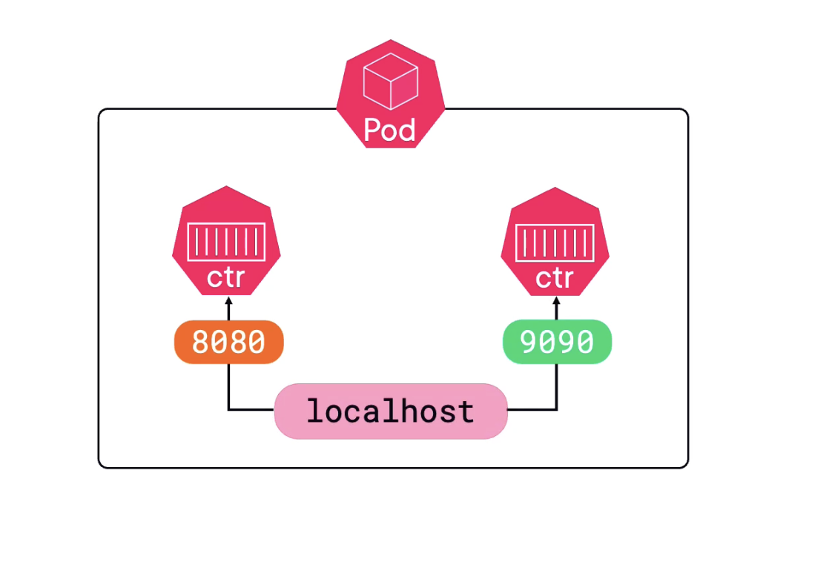

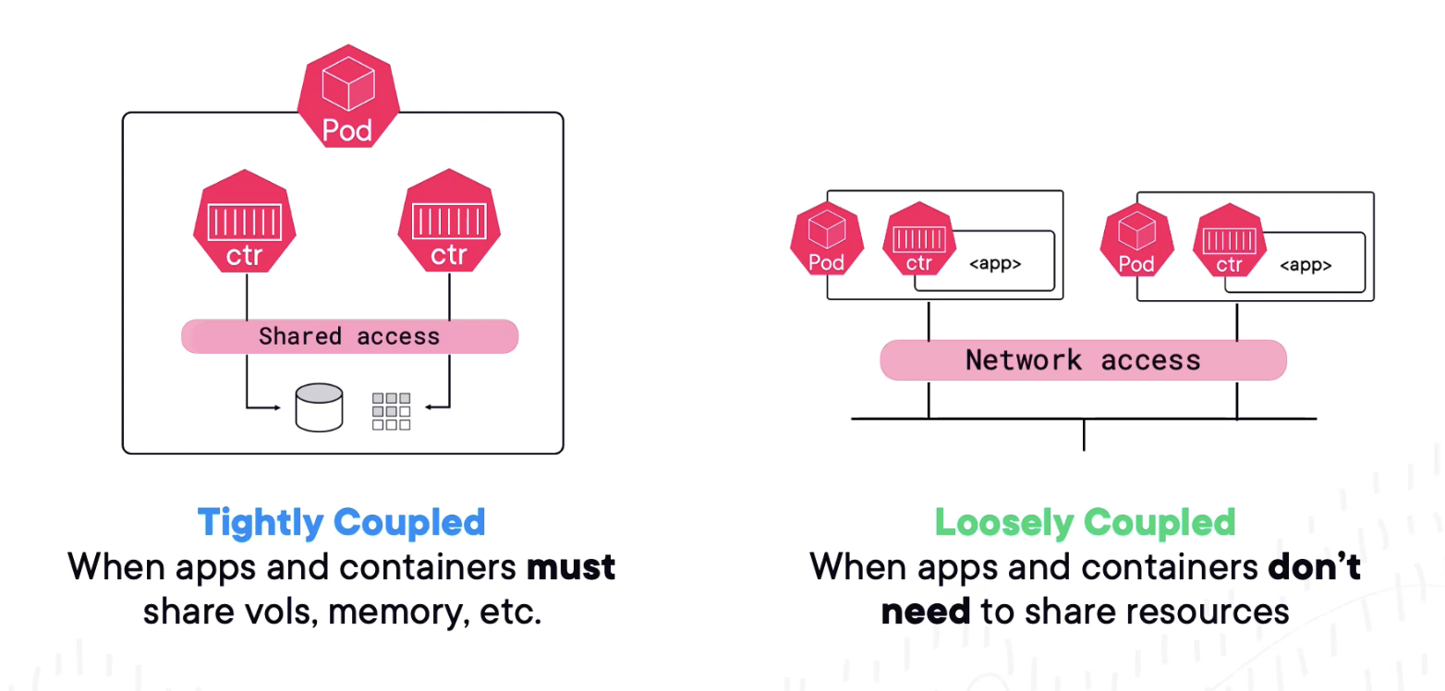

**NOTE:**

* **SCALE UP ADDS PODS**
* **SCALE DOWN REMOVE PODS**

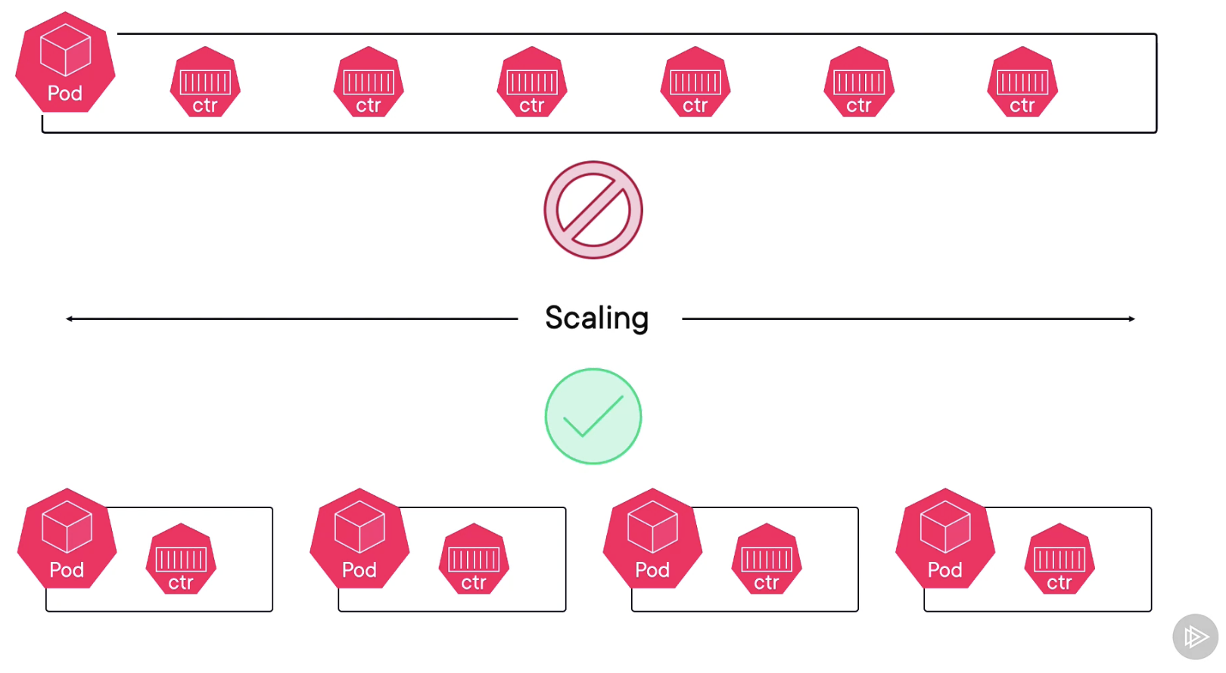

* A POD is only up if all the containers inside the pod is up
* We said POD is a single execution environment shared IP, shared Volume and Shared Memory
* Scheduling a pod is an all-or-nothing atomic operation to a single node.

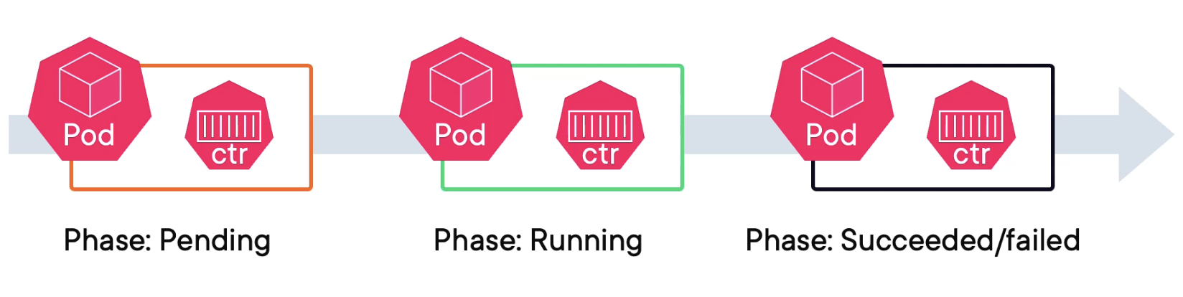

We deploy pods via some high-level controller like a deployment or a stateful set because these are what bring the good stuff like scaling and self healing and maybe ordered startup and persistent network IDs and stuff

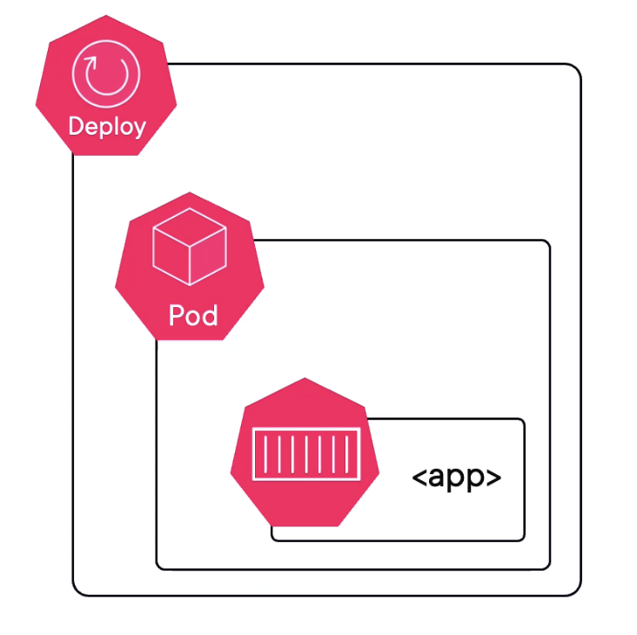

Why POD

* If there are not doing self healing or scaling up why can’t just containers
* PODS of course letting the kubernetes to do some accounting & management stuff
* They are great way to annotate, add custom labels, apply polices resources constraits
* 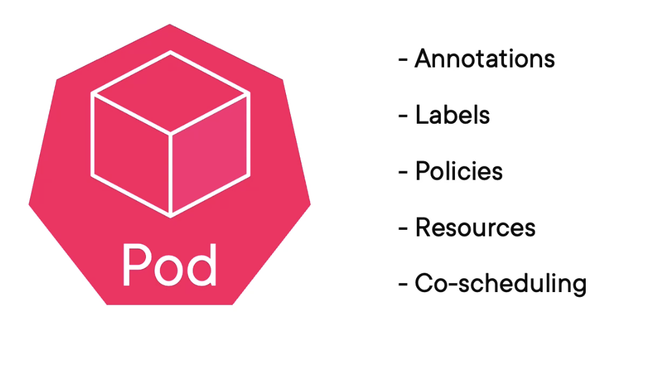

**Stable Networking with Services:**

* As we add (scale up) the pods or remove the pods we are just adding a new IP or deleting a new IP
* **So, we cannot rely on PODS IP. This is where Kubernetes service objects comes to rescue.**

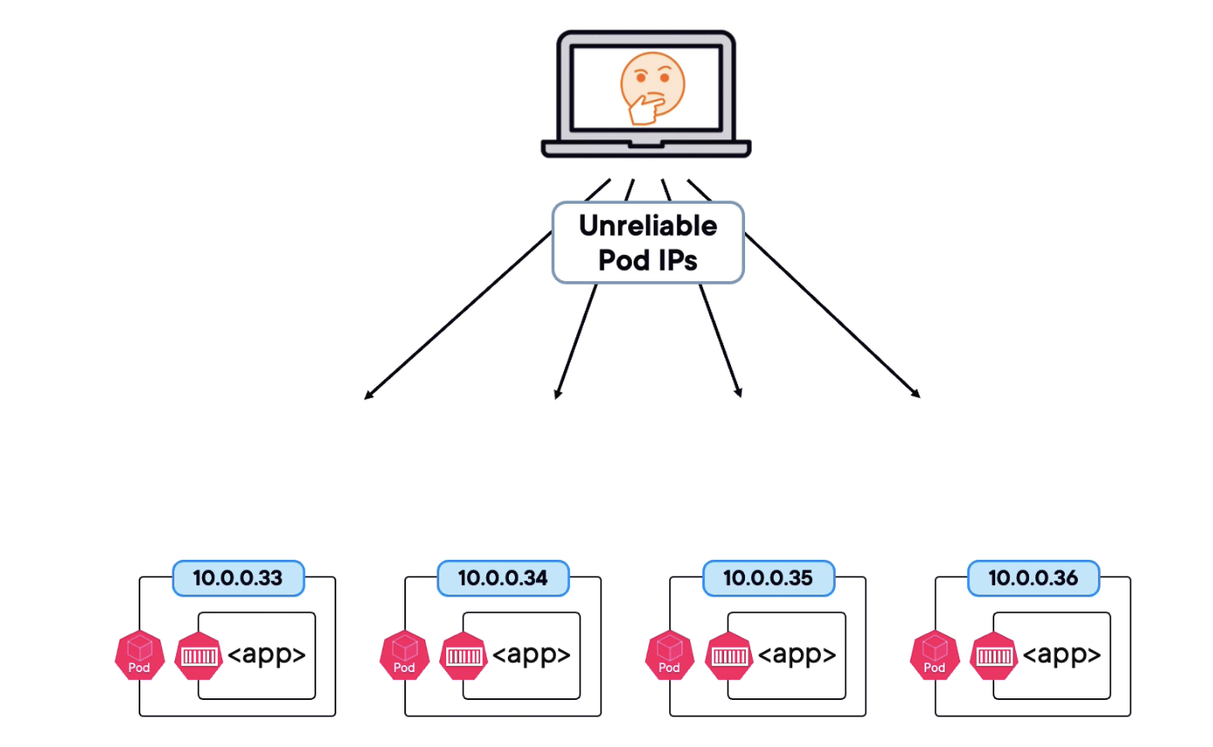

Stable IP and DNS will never changes it as PODS scale up and scale Down

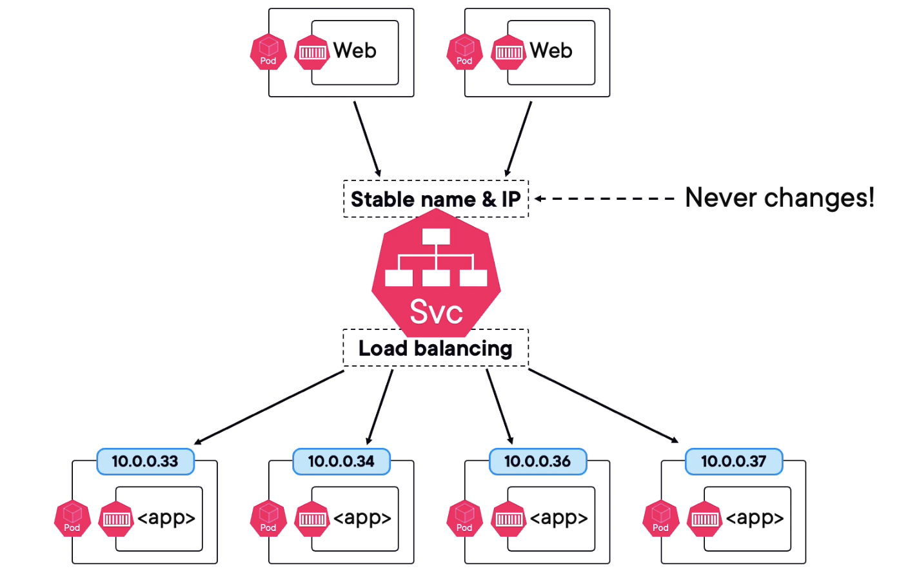

Now then, the way that a pod belongs to a service or makes it into the list of pods the service will forward traffic to it by using **labels.**

**When service is deciding which pods to load balance traffic to it uses a label-selector that say I am going to send traffic to all pods on the cluster that have these labels**

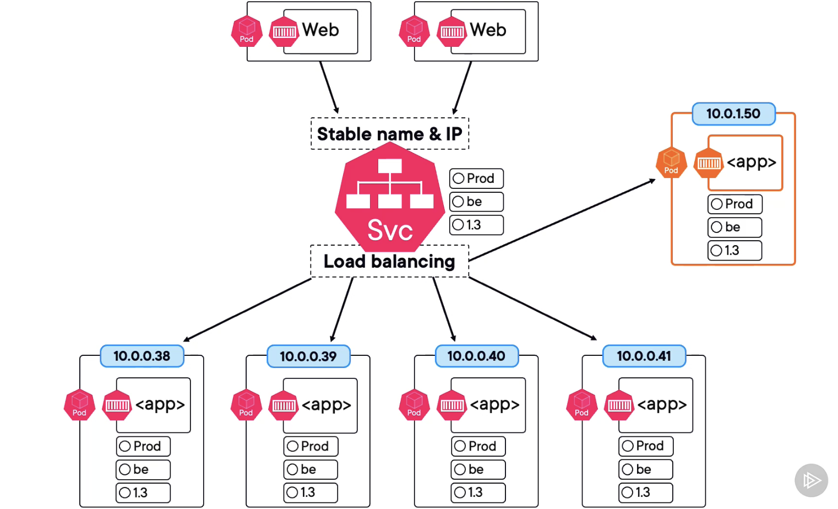

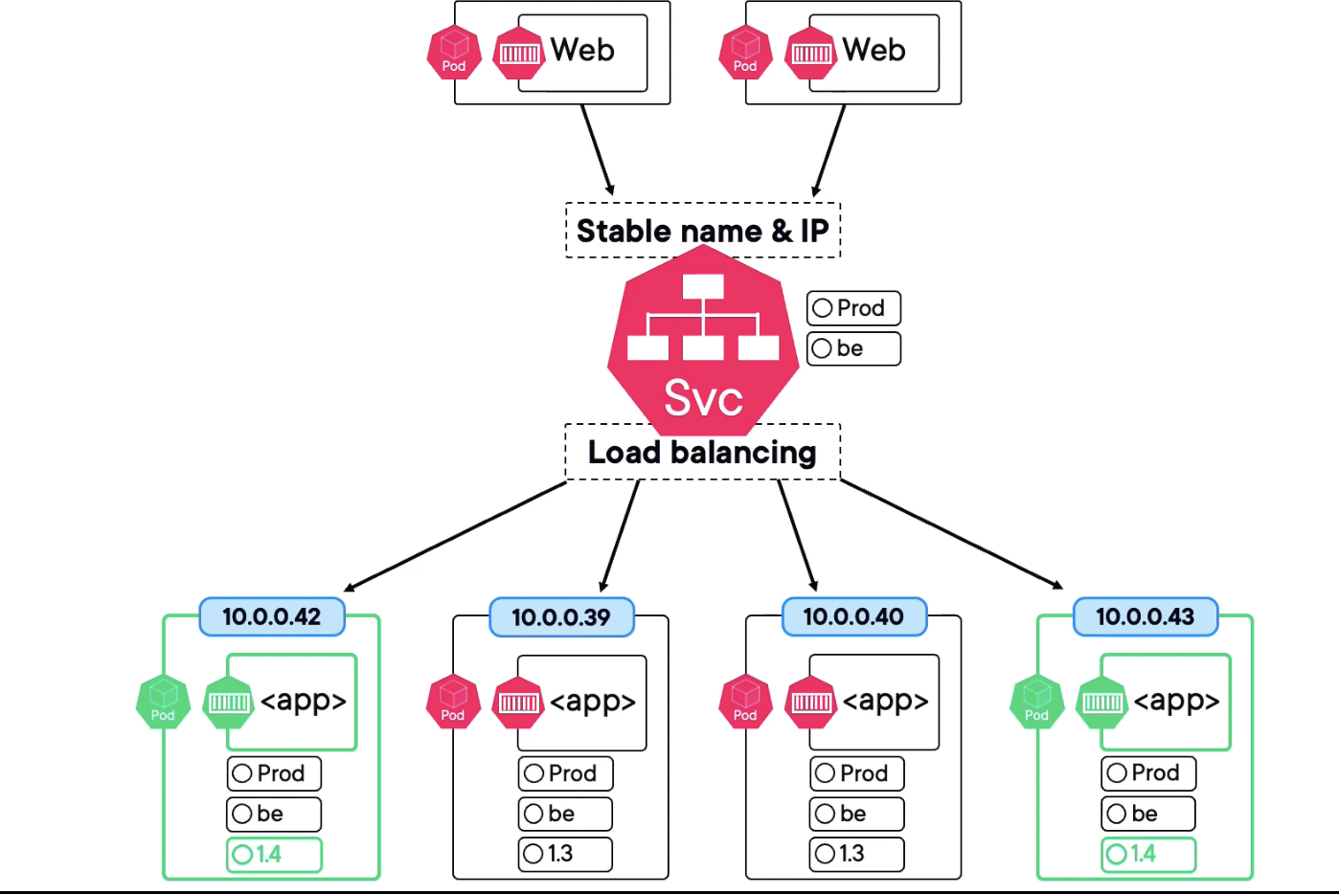

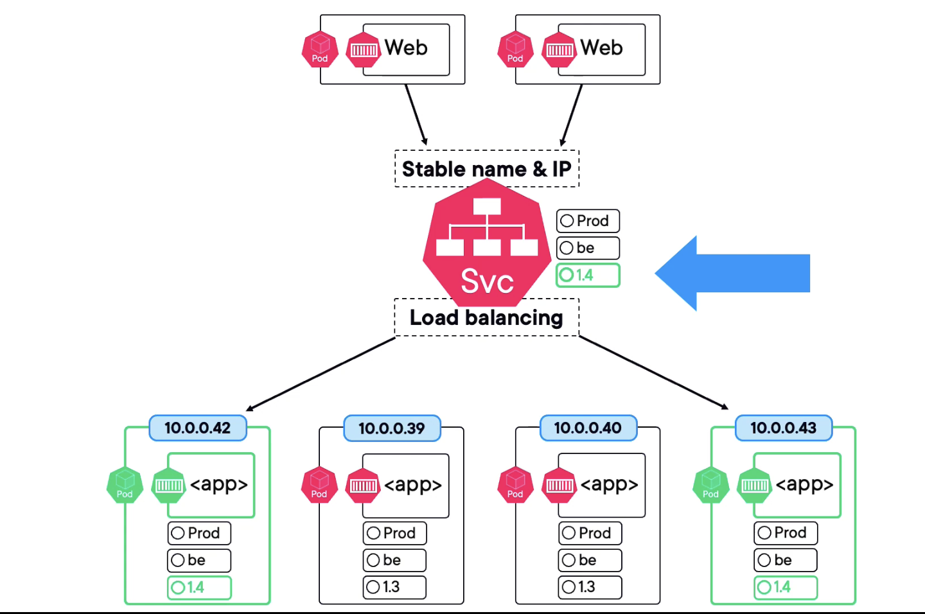

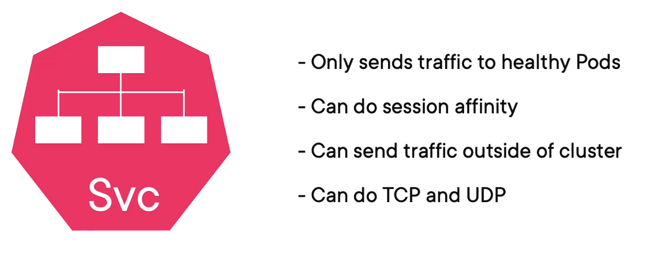

**Game-changing Deployments:**

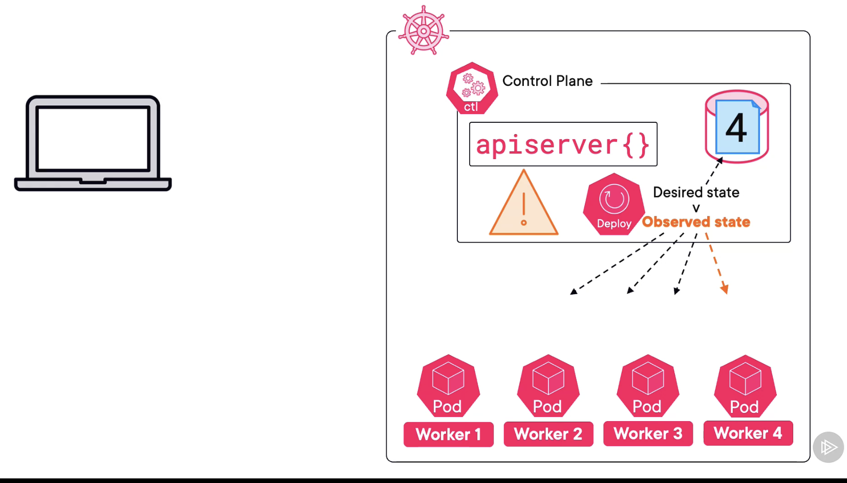

**Rs - replica sets**

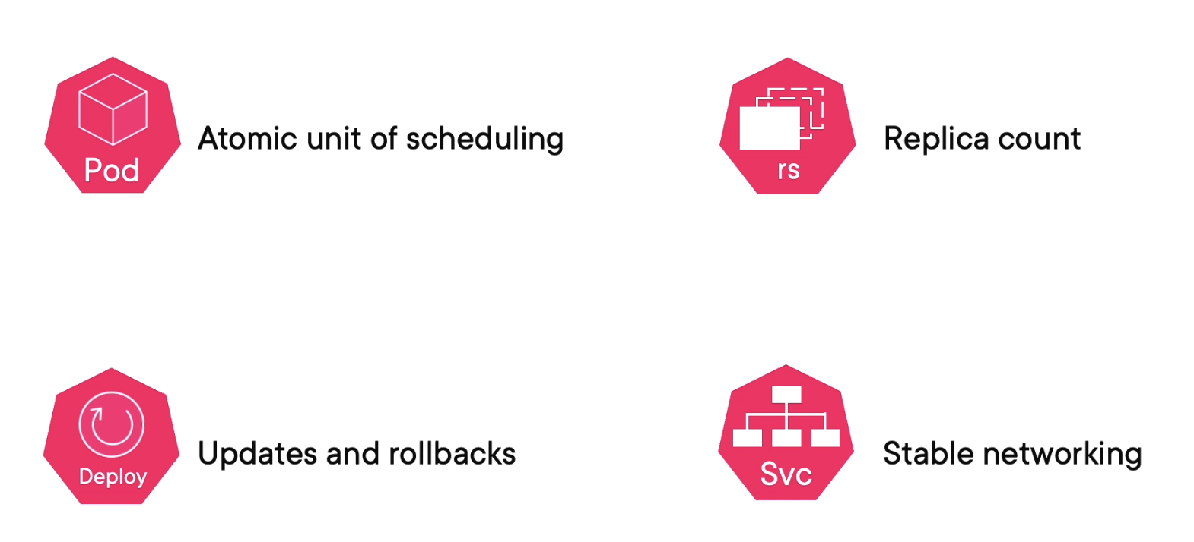

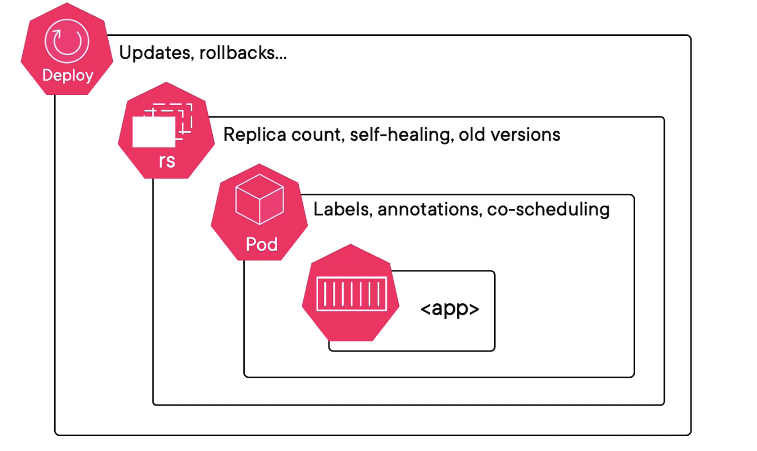

**Replicas means - PODs here let say if replica is 5 means 5 pods**

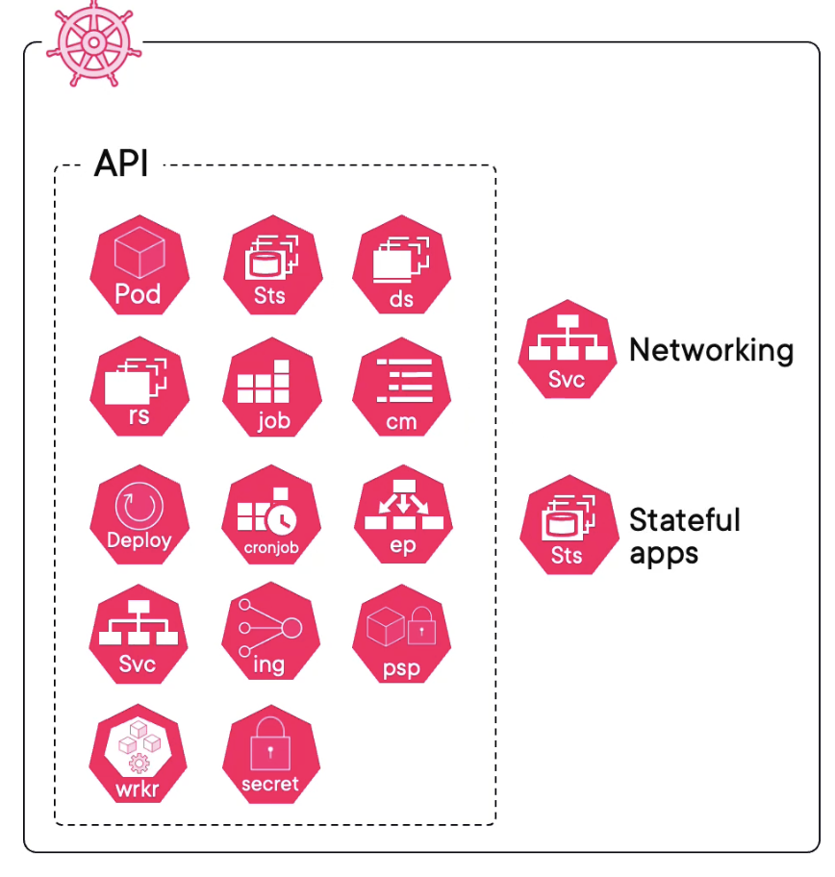

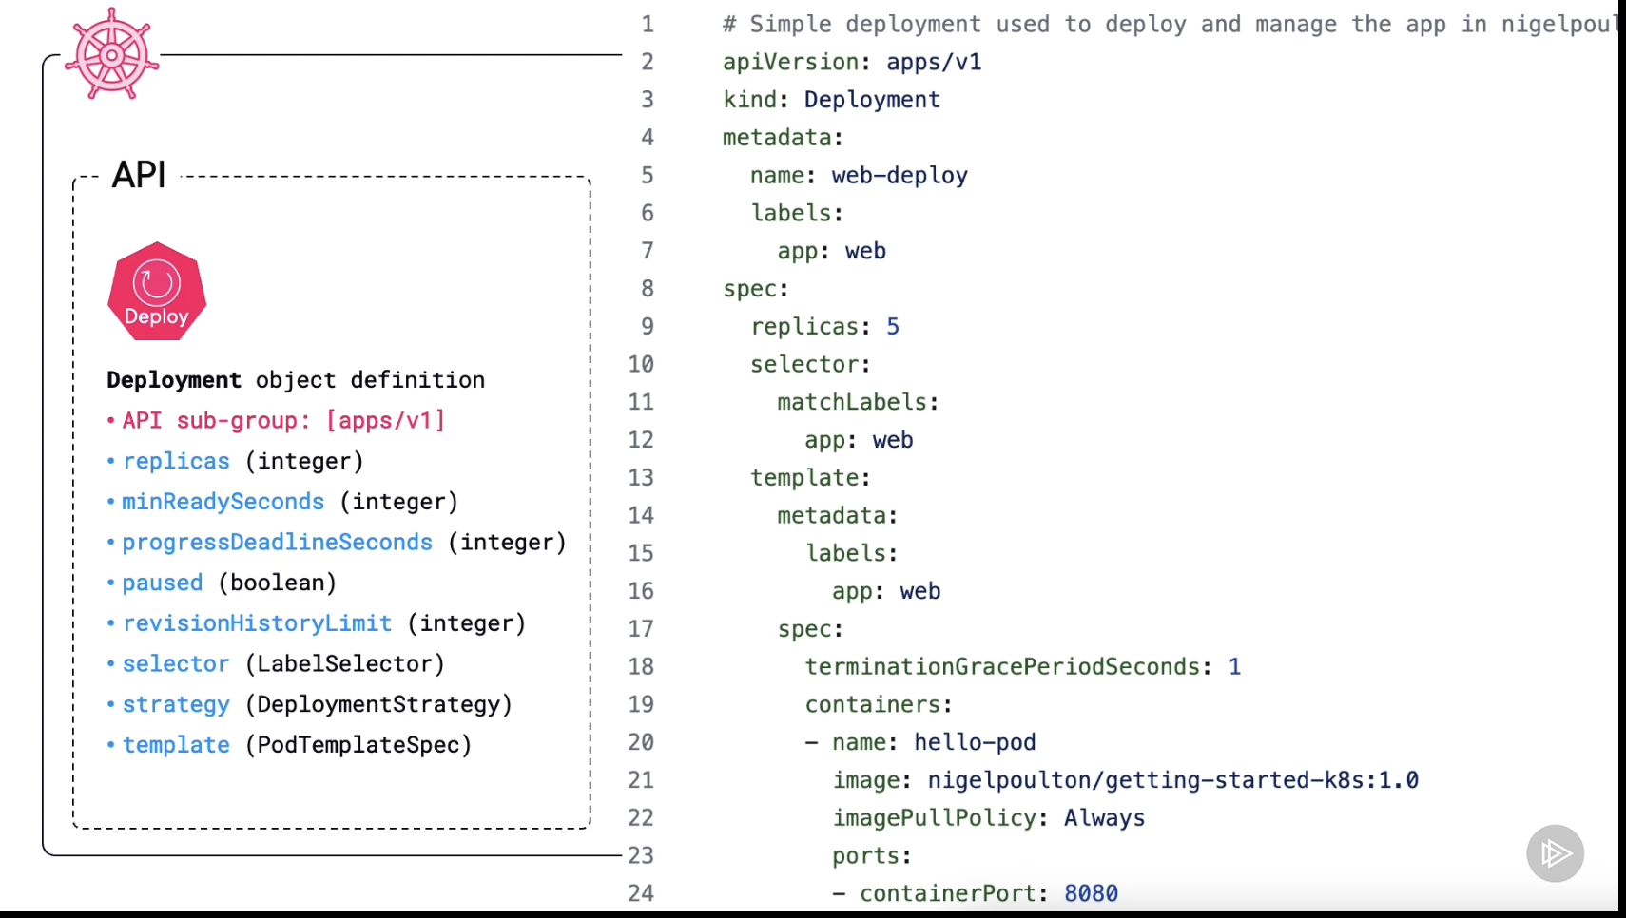

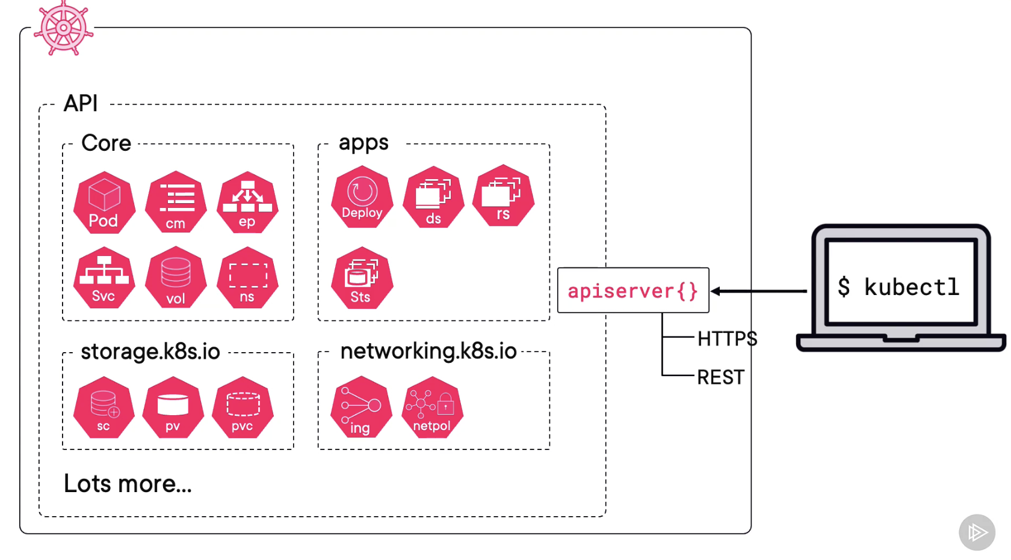

**Recap:**

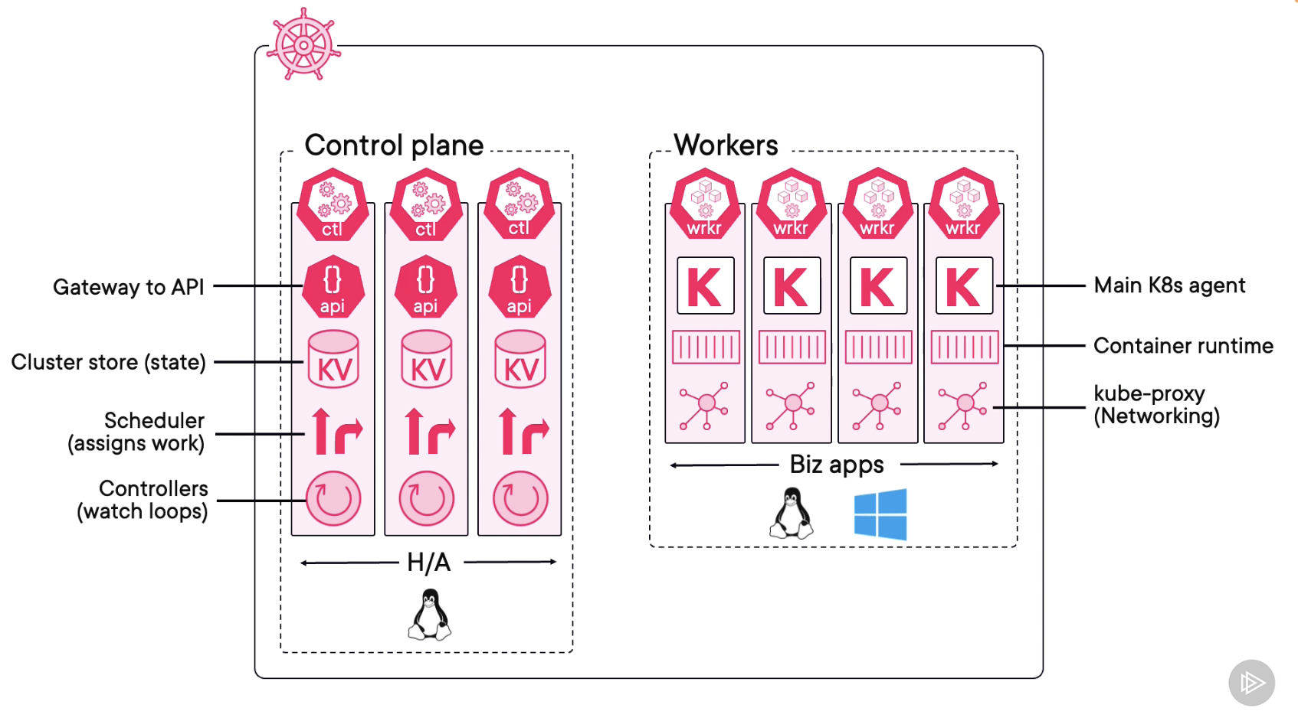

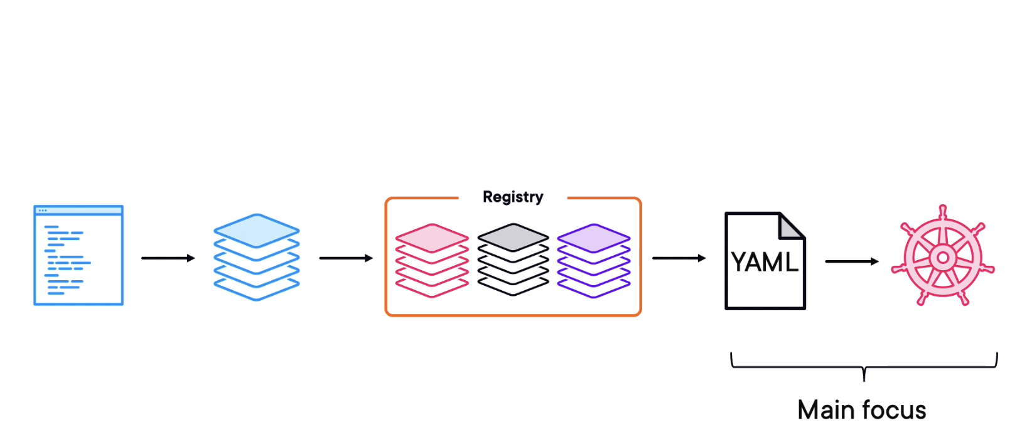

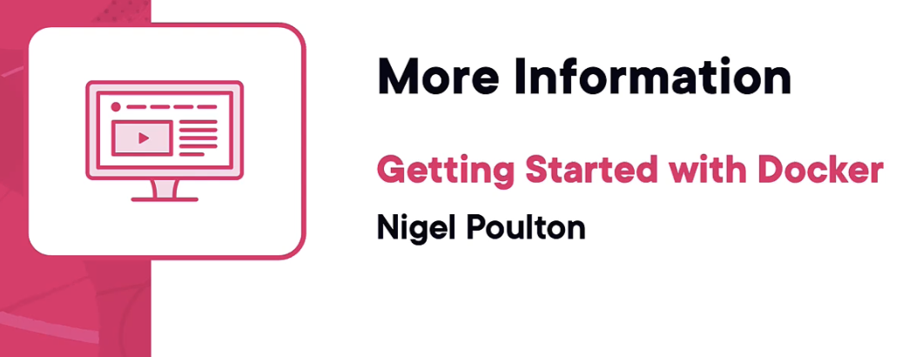

**Creating a Pod Manifest (YAML):**

**GA - General Availability**

**Alpha - first phase of testing, typically conducted internal by the development team or a select group of testers**

**Beta - second phase of testing, often released to a broader audience that may include external testers or early adopters**

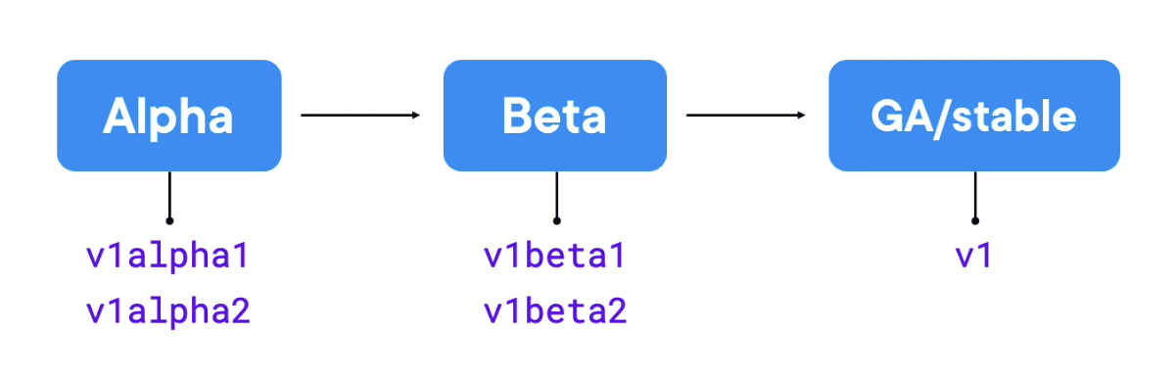

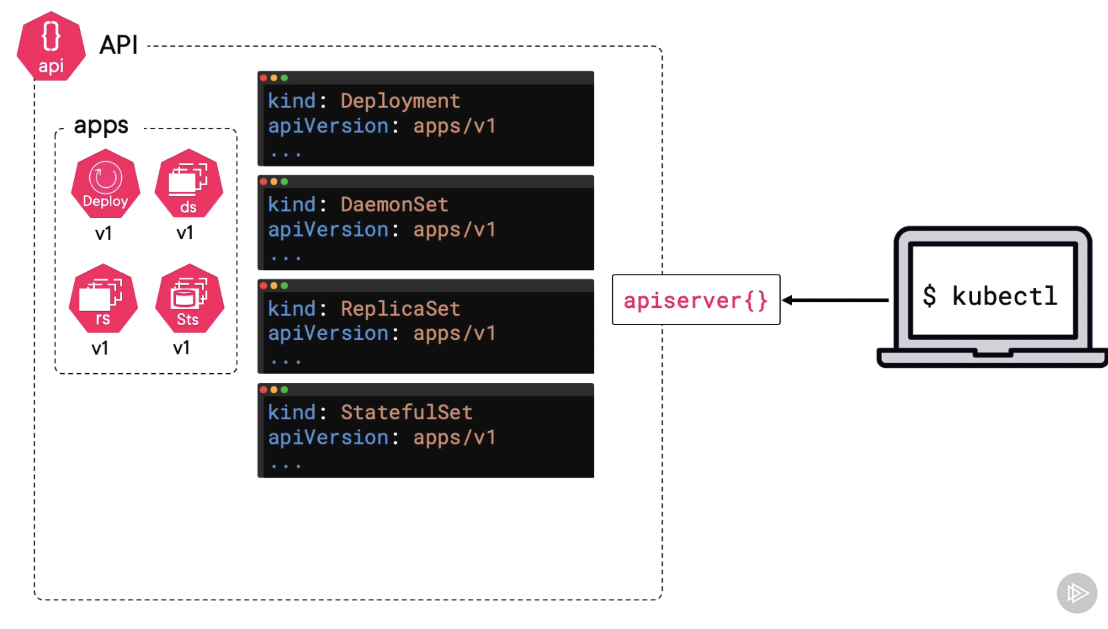

**Apps sub groups**

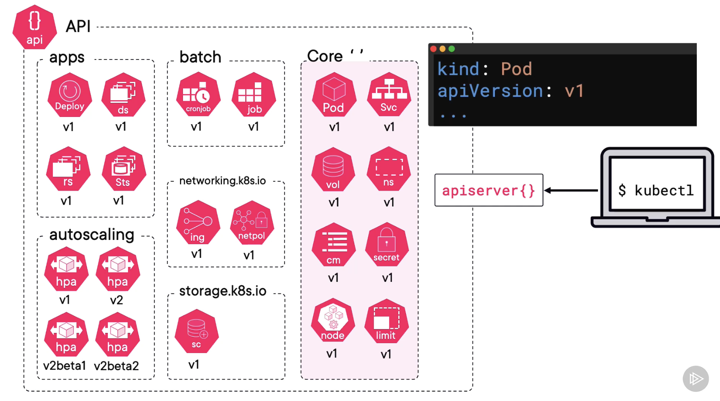

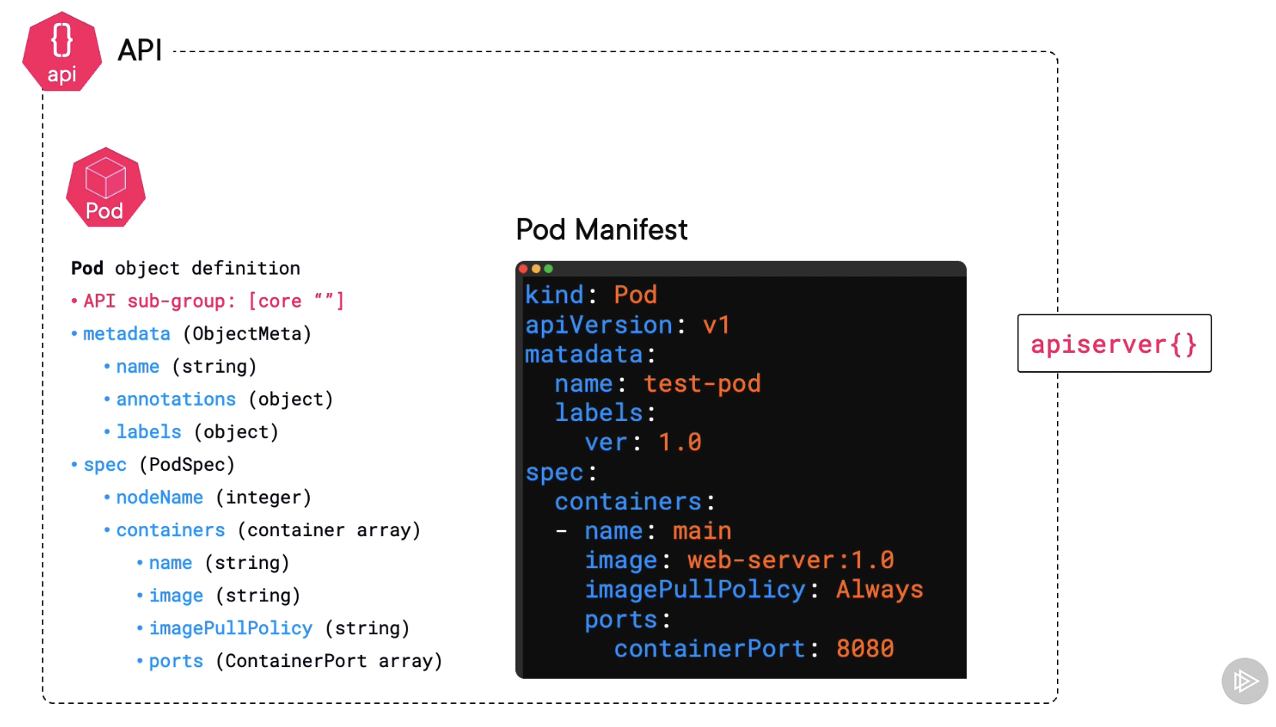

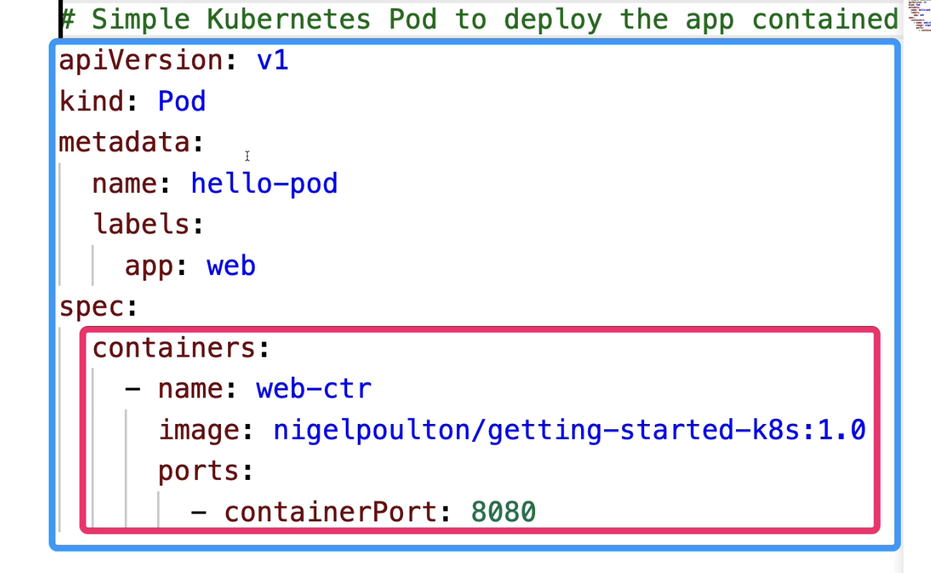

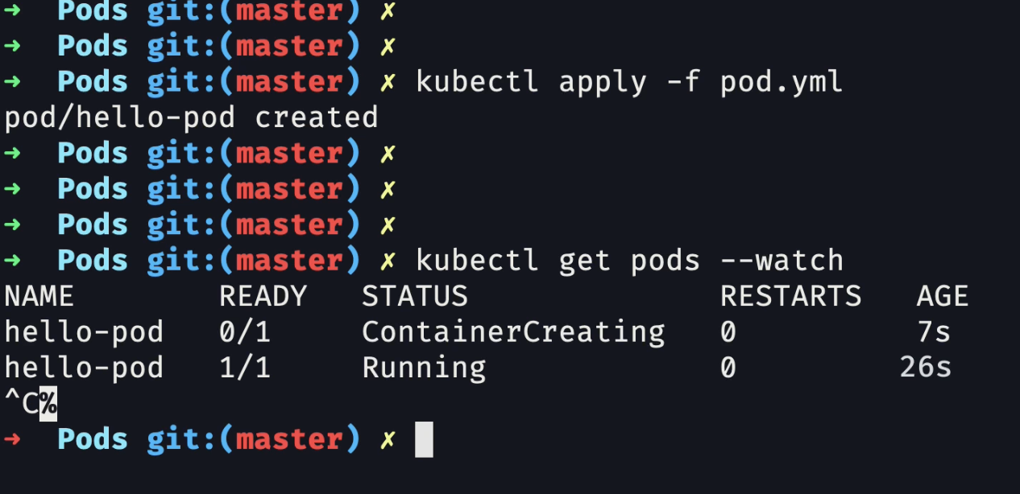

**Note:**

* **PODS runs on nodes**
* **Think of pods as apps and nodes as infrastructure**

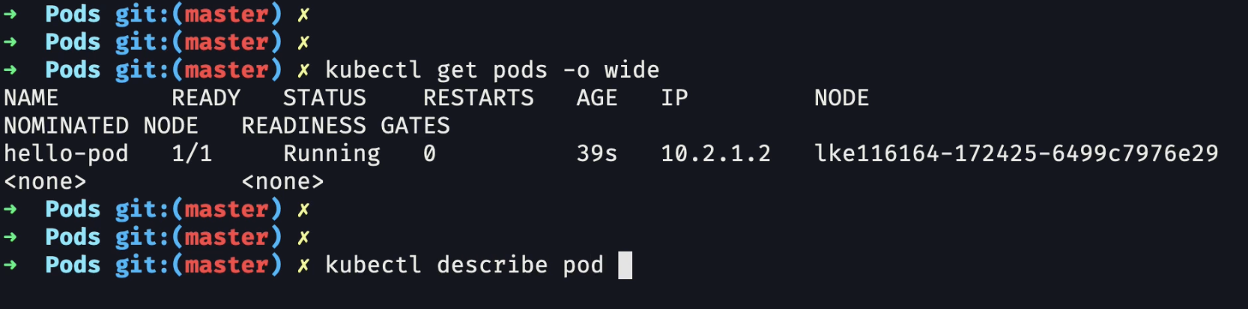

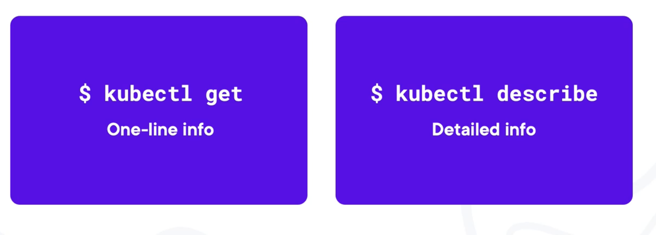

**Multi Container Pod Example:**

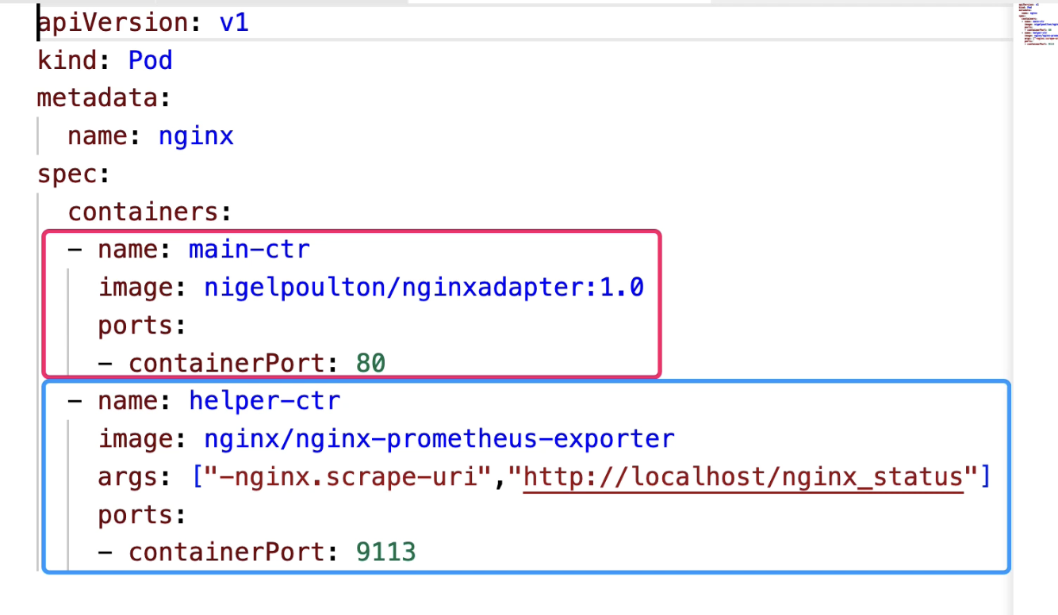

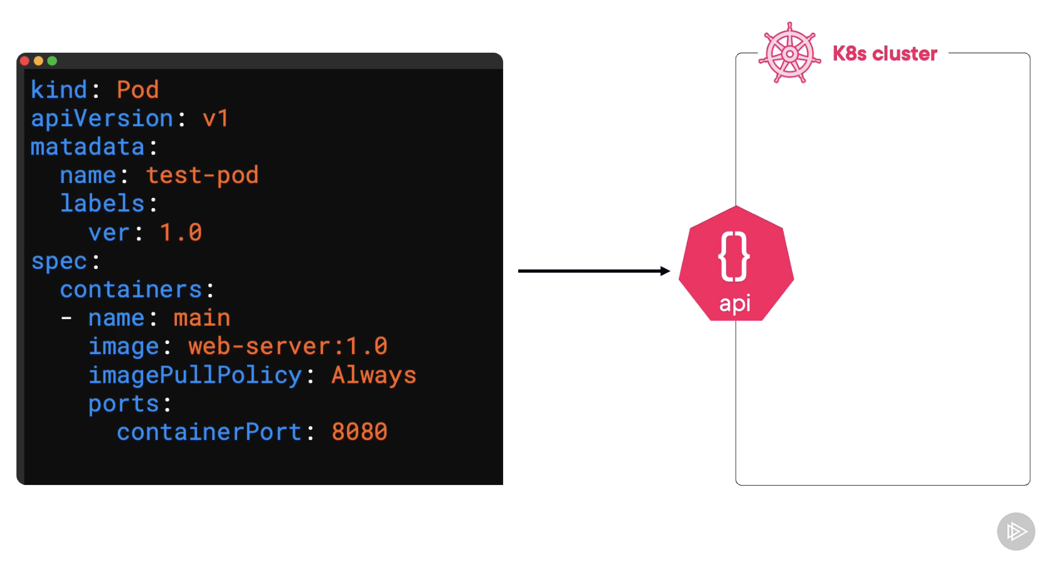

**Kubernetes Networking with service:**

* **The way in kubernetes to expose service**

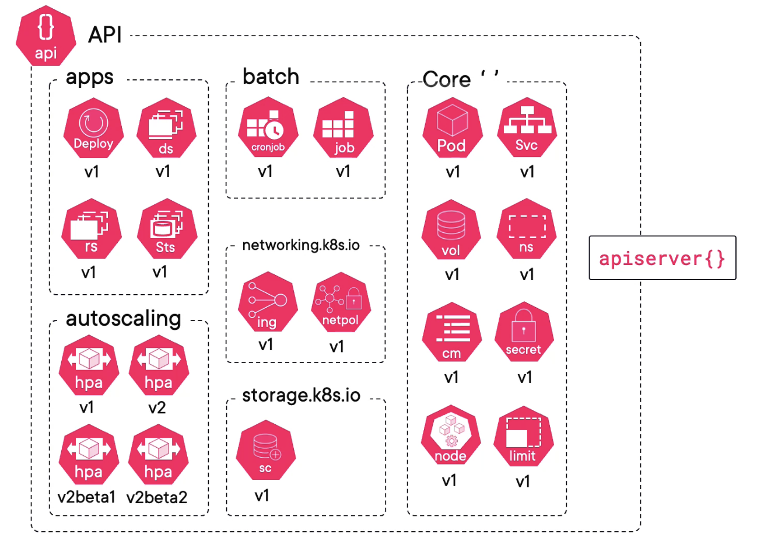

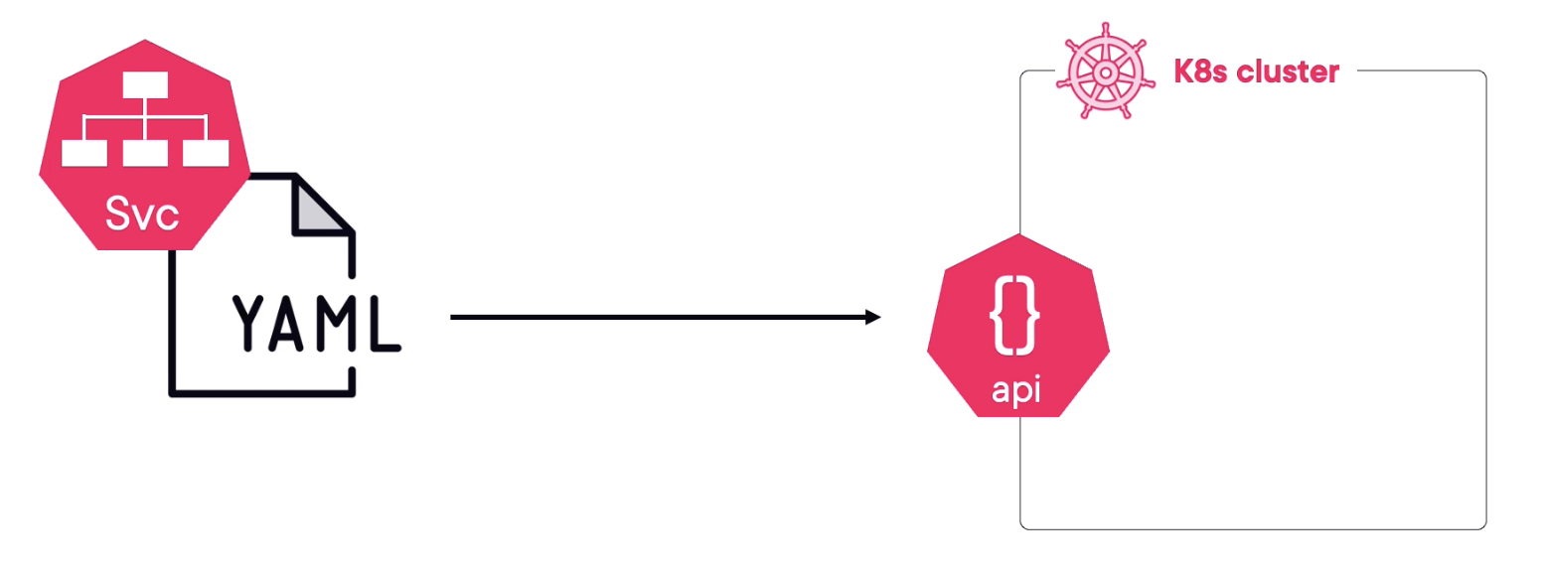

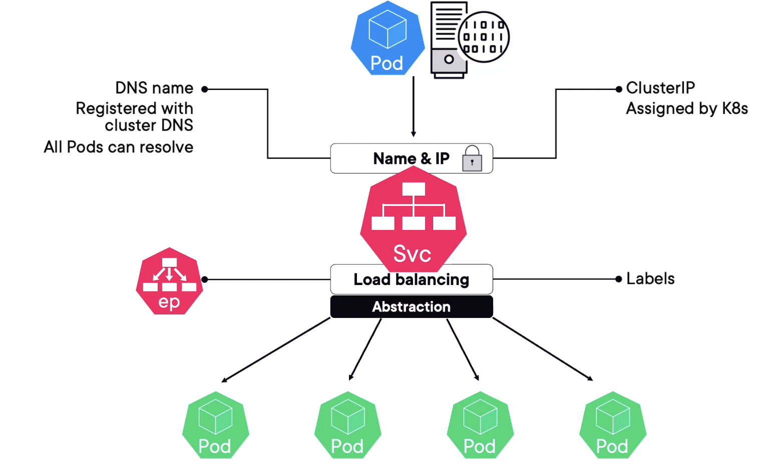

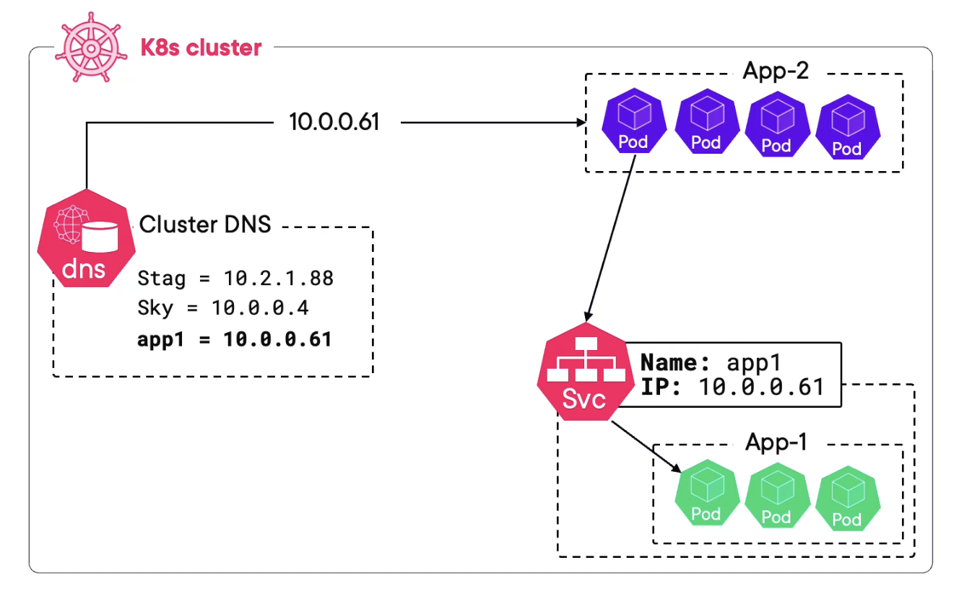

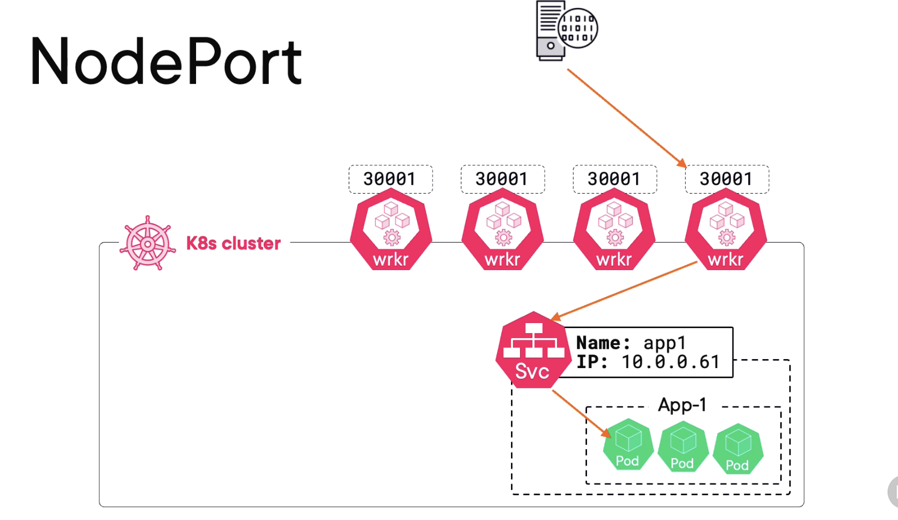

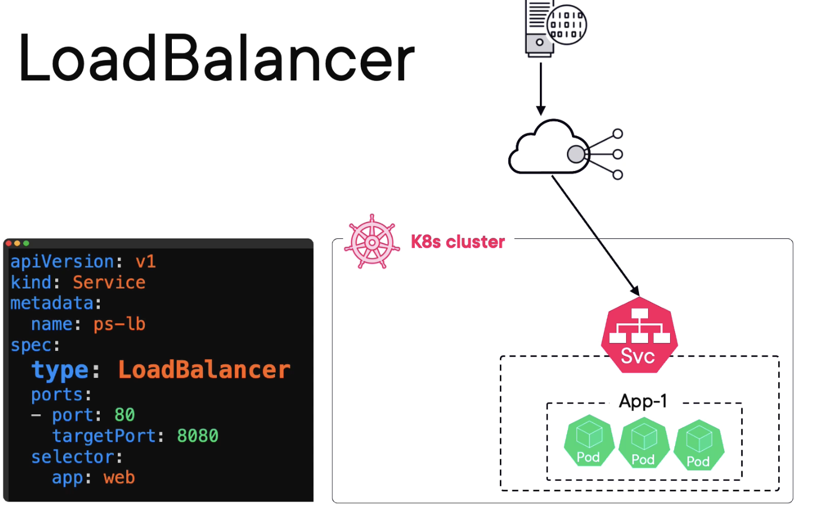

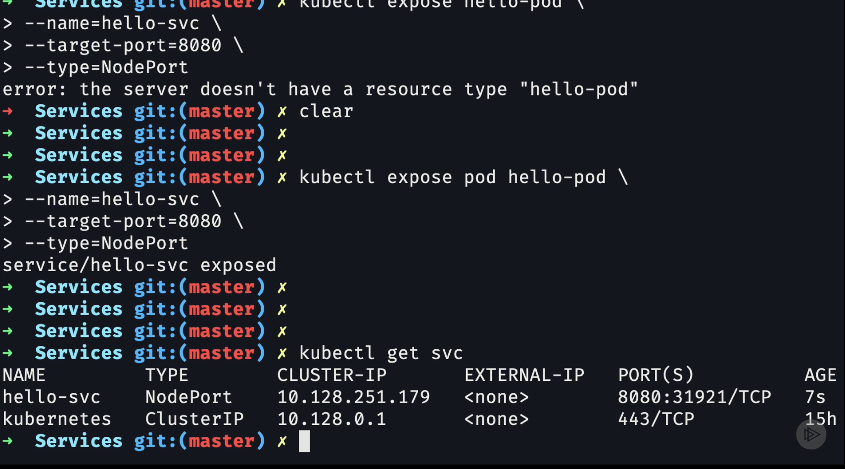

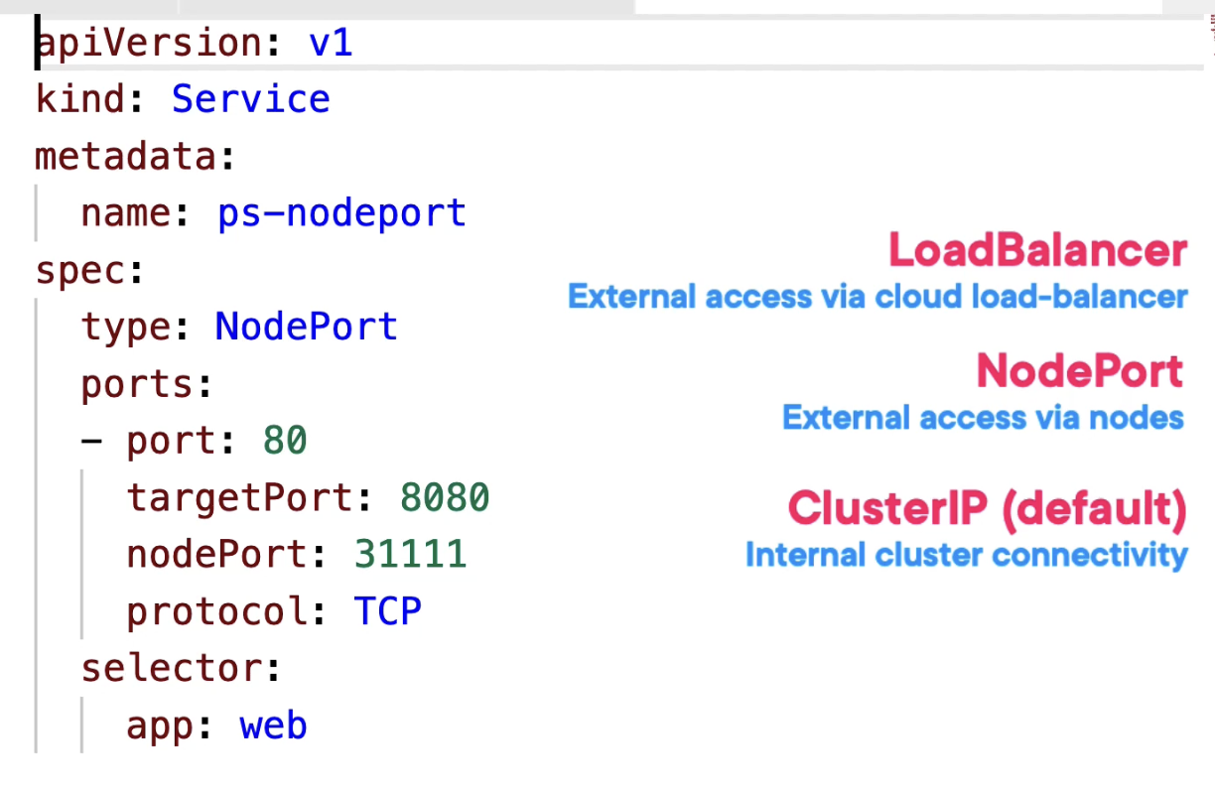

**Port:** port value is the port the service listens on inside the cluster.

* So, if another app on the same cluster is connecting via this name here (ps-nodeport) which remember is registered with DNS, well this is the internal port it needs to hit on
* **Exposes port (e.g:80) to handle incoming traffic and routes it to target port**

**Target Port:**

* Target port is the port the app container is listening on
* **The application is listening on target port (e,g. 8080)**

**Node Port:**

* Node port here is the external port that will be mapped on every cluster node (between 30000 and 32767)

Cluster IP: pod-to-pod communication

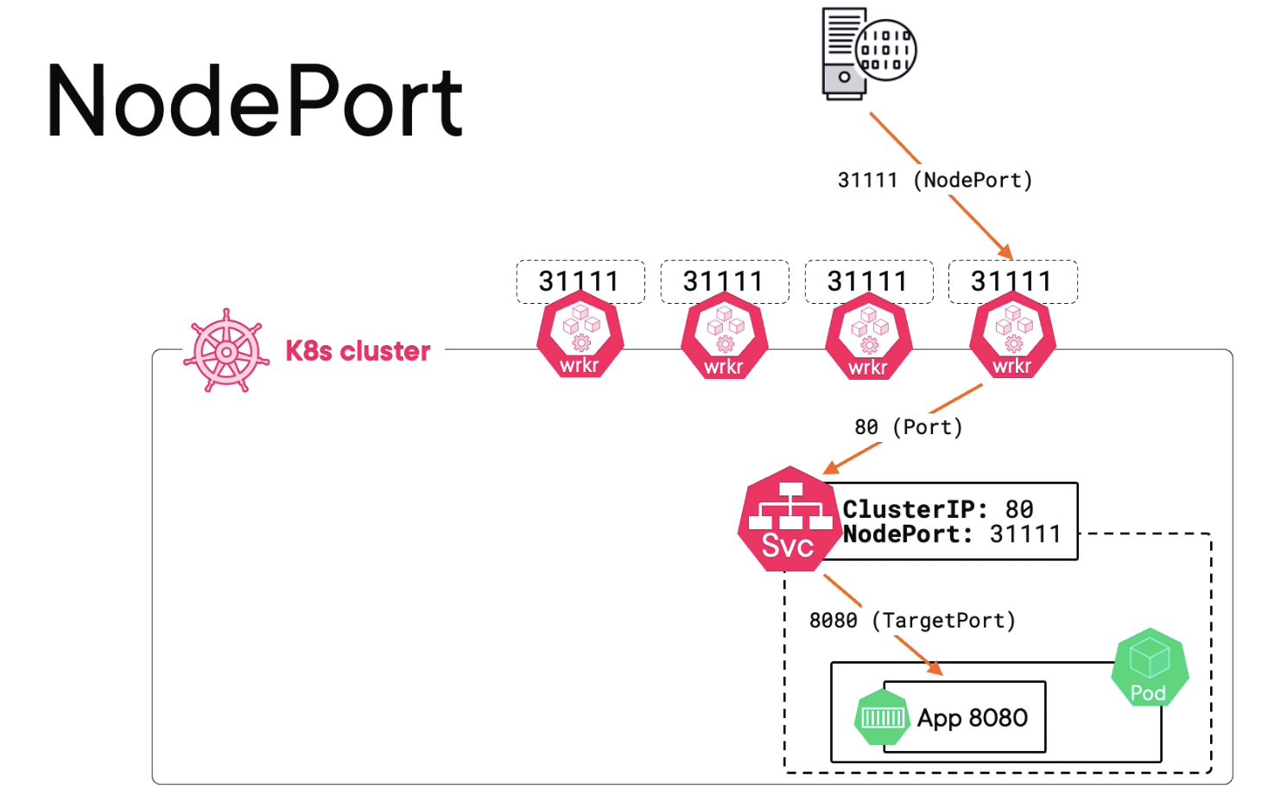

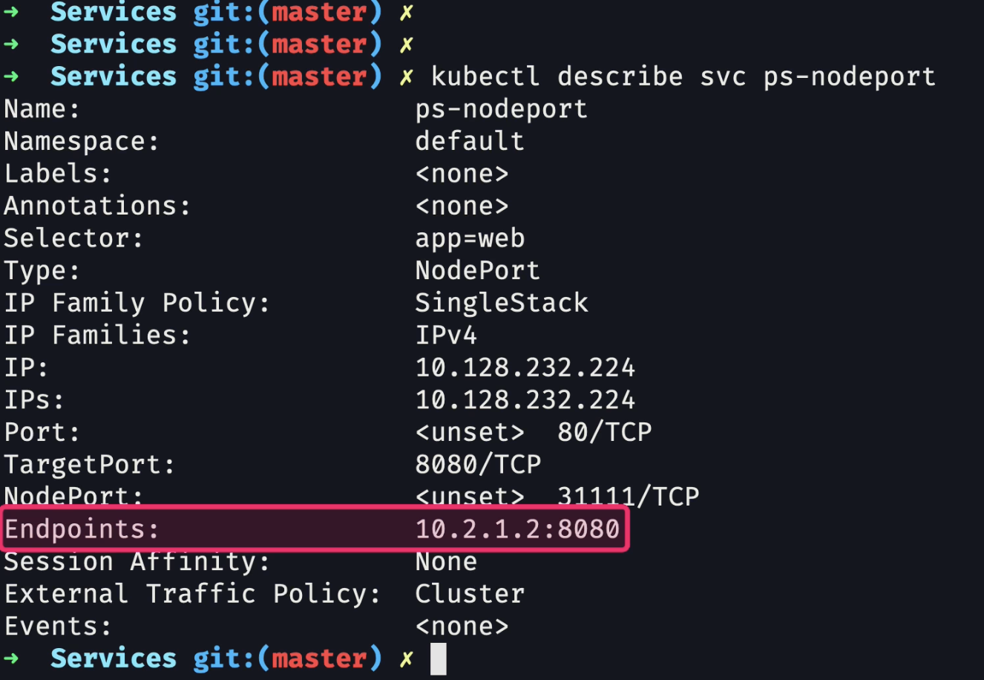

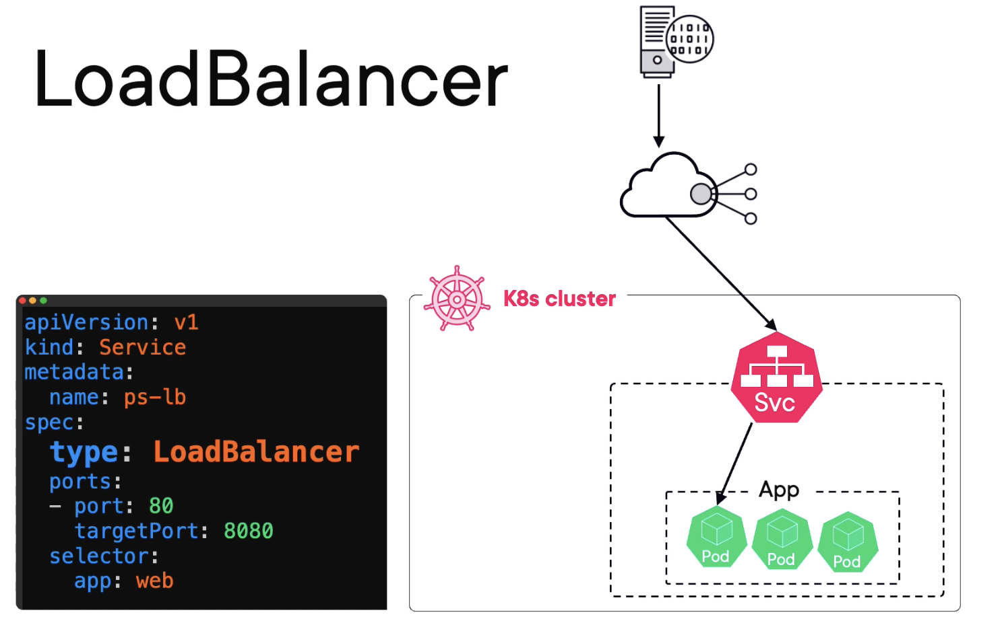

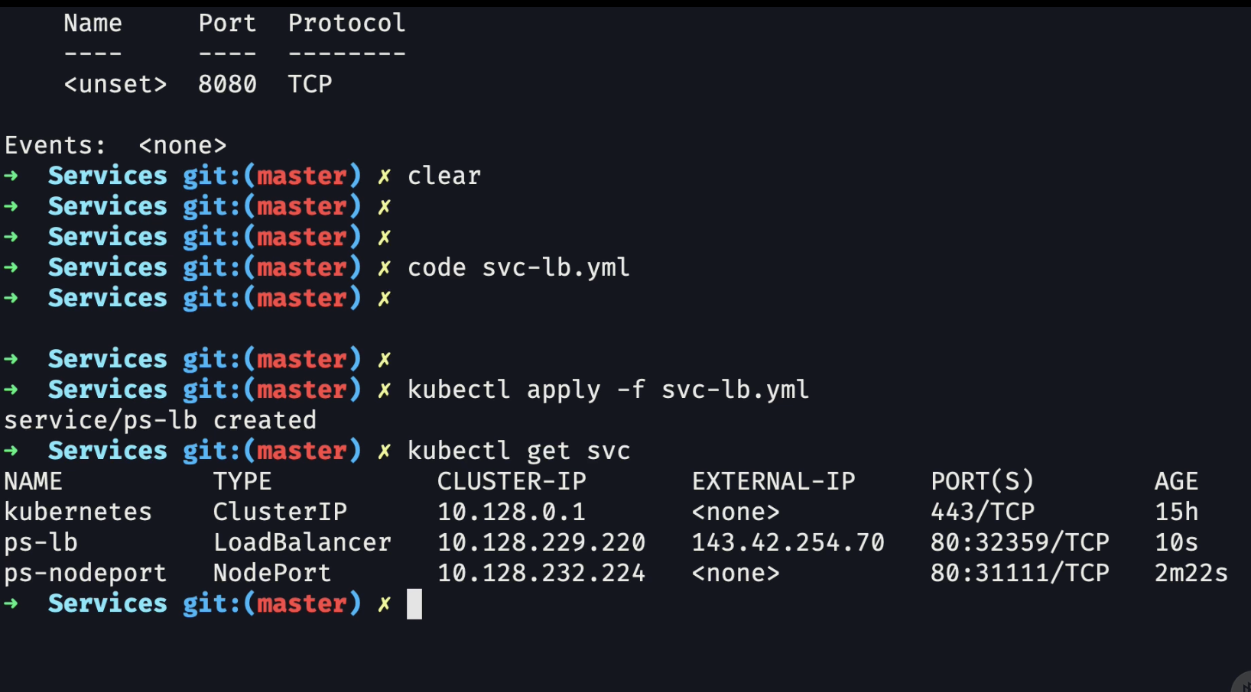

**Kubernetes Deployments:**

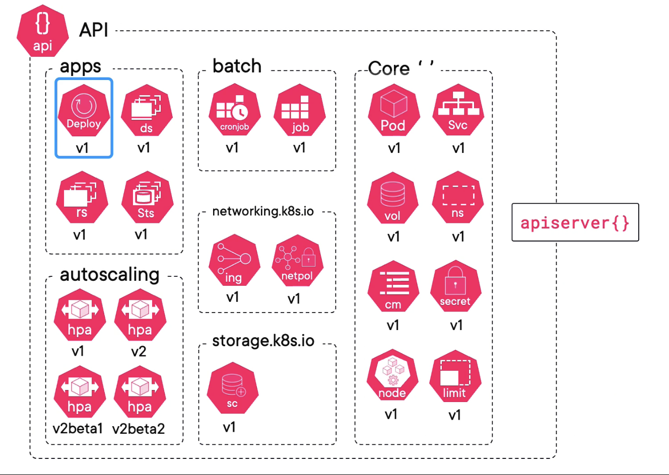

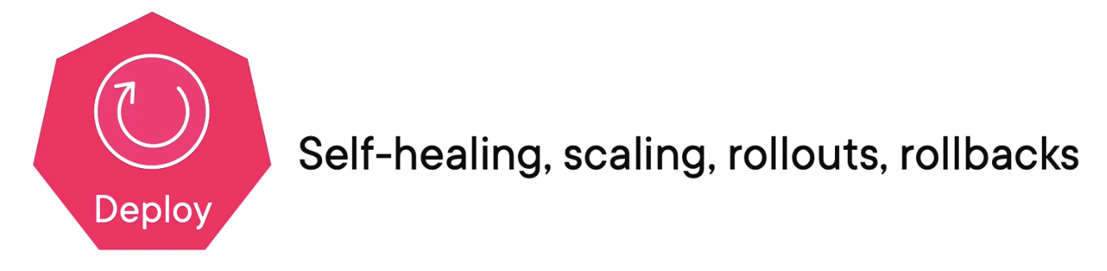

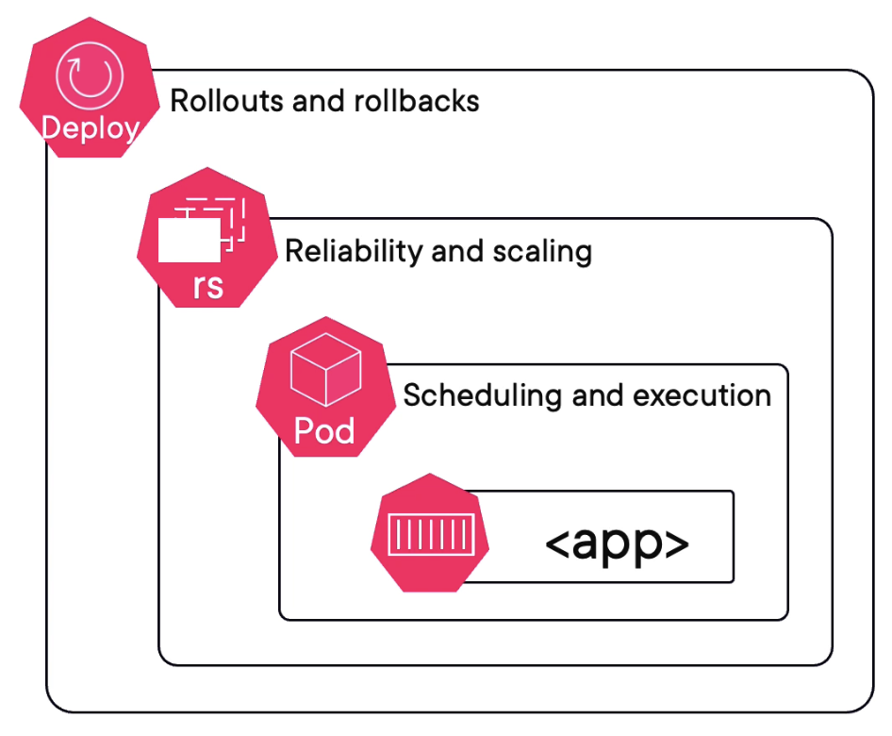

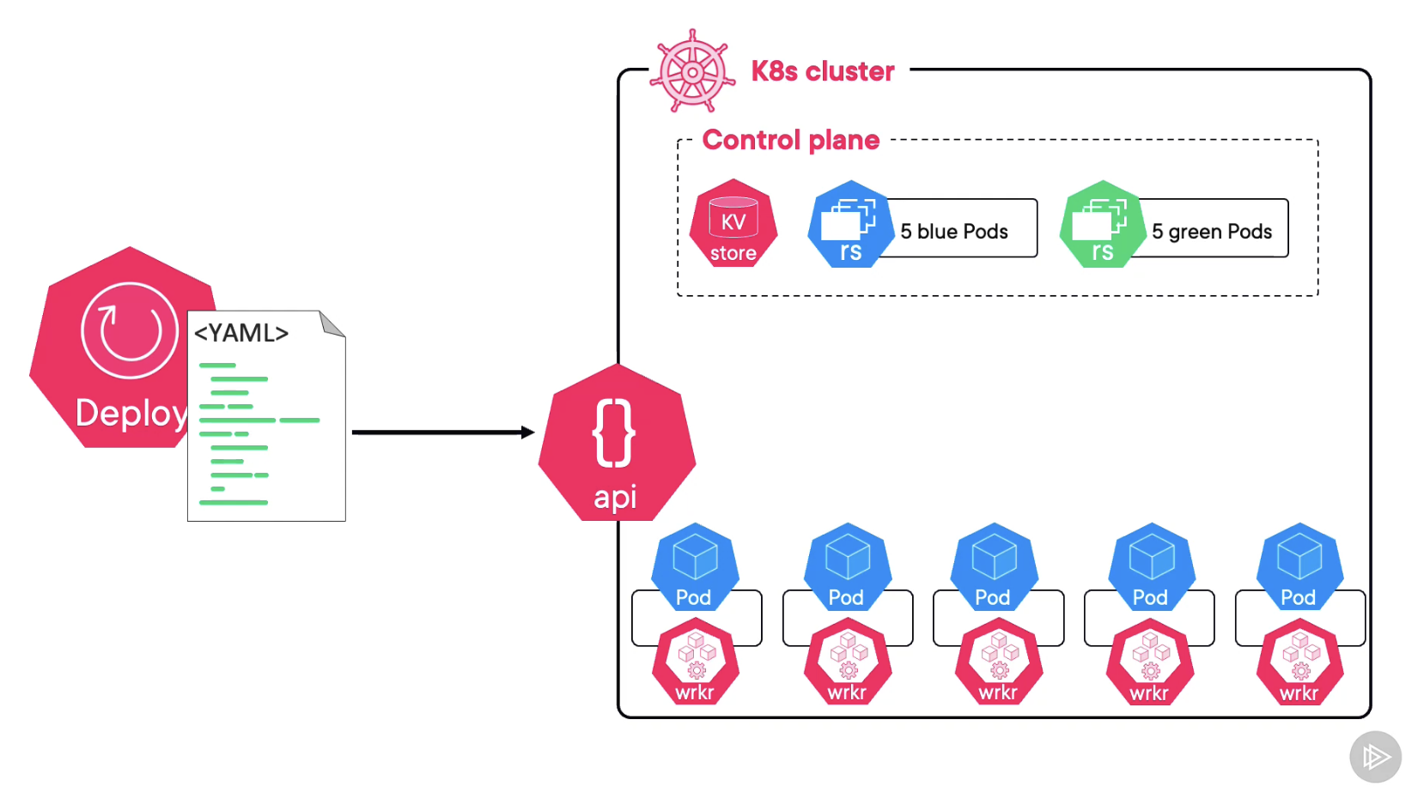

**Let say if we already have a replica set and if we made a changes to our image and a new image will be created and we will replace all old pods with the new pods, along side out old replica set is not went it is just simple keeping it there and we can easily roll back**

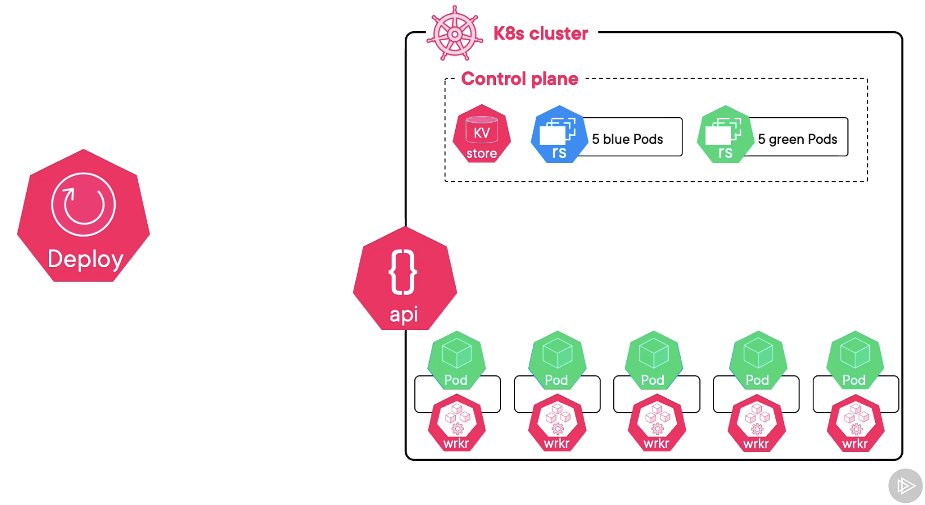

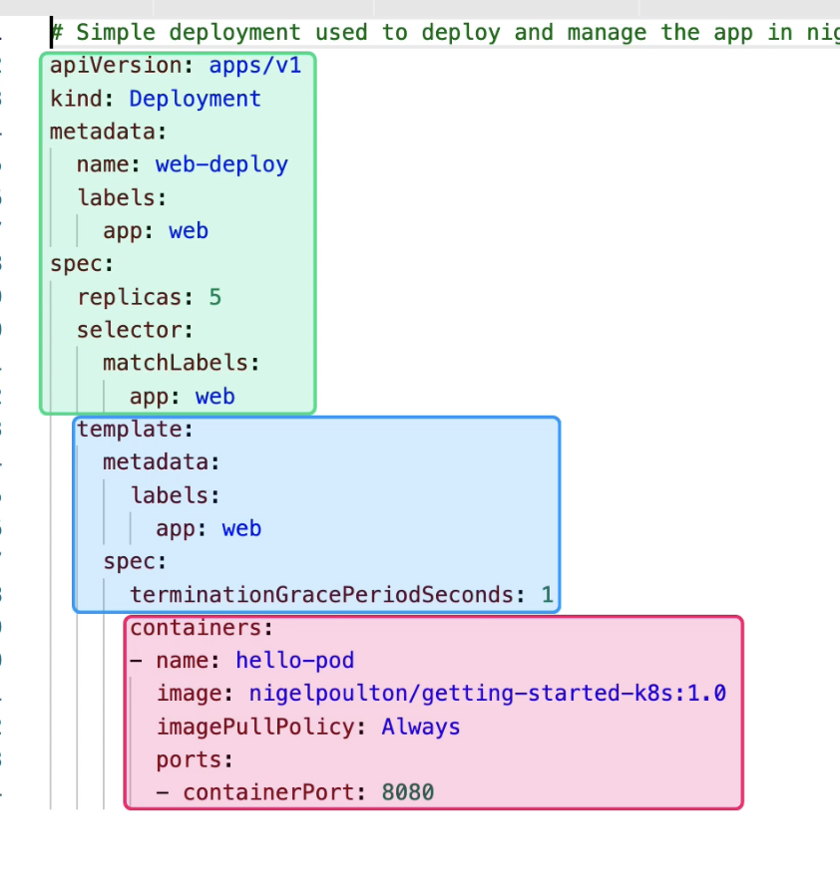

* **PINK:** Container Stuff
* BLUE: POD Stuff
* Green Deployment Spec

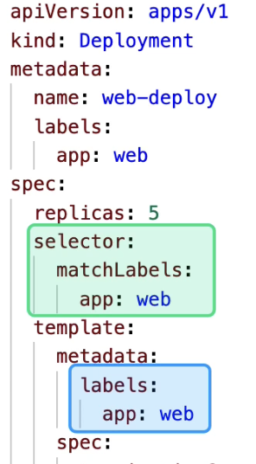

The label selector in the deployment spec must match the label spec in the pod spec. So, deployment can manages the right pods